Confidence-Driven Adaptive Multi-Sensor Fusion Framework for Robust Autonomous Vehicle Localization
K. Vishwa¹*
¹ Department of Computer Science and Engineering
Mahatma Gandhi Institute of Technology (MGIT)
Hyderabad – 500075, Telangana, India
E-mail: vishwa9821@gmail.com
Abstract
Accurate and reliable vehicle localization is essential for autonomous driving, particularly in complex and dynamic real-world environments where sensor performance can vary significantly due to changing illumination, GPS signal degradation, sensor noise, vehicle motion, and measurement uncertainty. Conventional multi-sensor fusion approaches typically rely on fixed sensor weights or predefined uncertainty models, limiting their ability to adapt to changing sensor reliability. To address this challenge, this paper proposes a Confidence-Driven Adaptive Multi-Sensor Fusion Framework for robust autonomous vehicle localization using synchronized camera, Global Positioning System (GPS), and Inertial Measurement Unit (IMU) data. The proposed framework introduces a Sensor Confidence Index (SCI) that estimates the reliability of each sensor by combining camera image quality metrics, GPS quality indicators, and IMU motion consistency measures into a unified confidence score. Based on the computed SCI, sensor weights are dynamically adjusted in real time and incorporated into an Adaptive Extended Kalman Filter (EKF), allowing the localization system to continuously adapt to varying sensing conditions. Additionally, a machine learning-based localization reliability prediction module is developed using confidence-aware localization features, where Linear Regression, Gradient Boosting Regression, and Random Forest Regression models are trained and evaluated to predict localization performance. The proposed framework is validated using the KITTI Raw Dataset, consisting of nine synchronized driving sequences with approximately 2,472 frames. Experimental results demonstrate that the confidence-driven adaptive fusion strategy consistently maintains accurate and reliable localization under diverse environmental conditions. Among the evaluated models, Random Forest Regression achieves the best performance with an RMSE of 0.0207 m, MAE of 0.0155 m, and an R² score of 0.9411, confirming the effectiveness of the proposed confidence-aware feature representation. Overall, the proposed framework provides a robust, scalable, and computationally efficient solution for adaptive multi-sensor localization by dynamically adjusting sensor contributions according to their real-time reliability, thereby improving localization accuracy and supporting dependable autonomous vehicle navigation in challenging real-world environments.Keywords— Autonomous vehicle localization, multi-sensor fusion, sensor confidence index, adaptive sensor weighting, confidence-driven sensor fusion, Extended Kalman Filter (EKF), camera–GPS–IMU integration, machine learning, Random Forest regression, KITTI Raw Dataset.
Keywords -- Autonomous vehicle localization, multi-sensor fusion, Sensor Confidence Index (SCI), adaptive sensor weighting, confidence-driven sensor fusion, Extended Kalman Filter (EKF), camera–GPS–IMU integration, localization reliability prediction, Random Forest Regression, KITTI Raw Dataset.
1 Introduction
Autonomous driving has emerged as one of the most significant advancements in intelligent transportation systems, with the potential to improve road safety, enhance traffic efficiency, and enable sustainable mobility. A reliable autonomous vehicle must continuously perceive its surroundings, accurately estimate its position, and make safe driving decisions in real time. Among these capabilities, vehicle localization is particularly critical because it directly affects trajectory planning, lane keeping, obstacle avoidance, navigation, and motion control. Even minor localization errors can accumulate over time, reducing navigation accuracy and potentially compromising the safety and reliability of autonomous driving systems. Therefore, developing robust and accurate localization techniques remains an active area of research.
Modern autonomous vehicles rely on multiple heterogeneous sensors to estimate vehicle position and motion. Cameras capture rich visual information that supports scene understanding, lane detection, traffic sign recognition, and object detection. The Global Positioning System (GPS) provides absolute positioning information, while the Inertial Measurement Unit (IMU) measures high-frequency vehicle motion through acceleration and angular velocity. Since these sensors provide complementary information, multi-sensor fusion has become the standard approach for improving localization accuracy and robustness. Among various fusion techniques, the Extended Kalman Filter (EKF) is widely used because of its recursive estimation capability, computational efficiency, and suitability for real-time localization.
Despite its widespread adoption, the performance of EKF-based sensor fusion largely depends on the quality of the incoming sensor measurements. In real-world driving environments, sensor reliability changes continuously due to environmental conditions and sensor limitations. Camera images may be degraded by poor lighting, rain, fog, motion blur, glare, shadows, or occlusions. GPS measurements can become inaccurate because of satellite blockage, multipath propagation, atmospheric disturbances, and urban canyon effects. Similarly, IMU measurements are affected by sensor bias, drift, vibration, and accumulated noise during long-term operation. Since these degradations rarely occur simultaneously, the reliability of each sensing modality varies independently over time.
Most existing localization methods address measurement uncertainty using fixed covariance matrices or predefined sensor weighting strategies. While these approaches perform well under normal operating conditions, they generally assume that sensor reliability remains constant throughout vehicle operation. In practice, however, sensing quality changes dynamically as the vehicle moves through different environments. As a result, assigning fixed importance to every sensor often produces suboptimal localization performance when one or more sensors become temporarily unreliable. Although recent studies have introduced adaptive uncertainty estimation using probabilistic models, Bayesian inference, or learning-based techniques, many of these methods estimate uncertainty only after sensor measurements have already been fused. Moreover, relatively few approaches evaluate the quality of individual sensors before fusion by jointly considering camera quality, GPS reliability, and IMU motion consistency within a unified confidence estimation framework.
Another limitation of current localization systems is their inability to explicitly estimate the reliability of the predicted vehicle position. Most algorithms provide only the estimated location without indicating how trustworthy that estimate is under different sensing conditions. Confidence-aware localization can supply valuable information to higher-level autonomous driving modules, including path planning, behavior prediction, decision-making, and safety management. By understanding the confidence associated with localization results, these modules can make safer and more informed decisions, especially in challenging environments.
To address these limitations, this paper proposes a Confidence-Driven Adaptive Multi-Sensor Fusion Framework for robust autonomous vehicle localization using synchronized camera, GPS, and IMU measurements. The proposed framework introduces a Sensor Confidence Index (SCI) that provides a unified measure of sensor reliability by combining multiple camera image quality metrics, GPS quality indicators, and IMU motion consistency measures. The computed SCI is then used to determine adaptive sensor weights, allowing an Adaptive Extended Kalman Filter (EKF) to dynamically adjust the contribution of each sensing modality according to its real-time reliability. In addition, a machine learning-based localization reliability prediction module is developed using confidence-aware localization features. Linear Regression, Gradient Boosting Regression, and Random Forest Regression models are trained and evaluated to predict localization performance under varying sensing conditions. The proposed framework is validated using the KITTI Raw Dataset, which includes nine synchronized driving sequences containing approximately 2,472 frames, demonstrating improved localization robustness and reliable confidence estimation across diverse driving environments.
The main contributions of this paper are summarized as follows:
- A unified Sensor Confidence Index (SCI) is proposed to quantify the real-time reliability of camera, GPS, and IMU sensors by integrating multiple sensor-specific quality indicators into a single interpretable confidence score.
- A confidence-driven adaptive sensor weighting strategy is developed to dynamically adjust the contribution of each sensing modality according to its estimated reliability, enabling more robust multi-sensor fusion under changing environmental and sensing conditions.
- A confidence-aware Adaptive Extended Kalman Filter (EKF) is designed to incorporate adaptive sensor weights into recursive state estimation, improving localization robustness in the presence of sensor degradation and measurement uncertainty.
- A machine learning-based localization reliability prediction module is introduced using confidence-aware localization features, where Linear Regression, Gradient Boosting Regression, and Random Forest Regression models are trained and evaluated to predict localization performance.
- Comprehensive experimental validation is conducted using the KITTI Raw Dataset across nine synchronized driving sequences, demonstrating the effectiveness of the proposed framework in terms of localization accuracy, confidence estimation, adaptive sensor weighting, and localization reliability prediction.
2 Literature review
2.1 Multi-Sensor Fusion for Autonomous Vehicle Localization
Accurate vehicle localization is a fundamental requirement for autonomous driving because it directly supports navigation, trajectory planning, obstacle avoidance, and motion control. Since no single sensor can provide reliable localization under all driving conditions, modern autonomous vehicles employ multiple heterogeneous sensors, including cameras, Global Positioning System (GPS), Inertial Measurement Units (IMUs), LiDAR, and radar. Each sensing modality offers unique strengths and limitations: cameras capture rich visual and semantic information, GPS provides absolute positioning, IMUs measure high-frequency vehicle motion, while LiDAR and radar deliver accurate geometric and distance measurements. By combining these complementary sensing modalities, multi-sensor fusion has become the standard approach for improving localization accuracy, robustness, and reliability across diverse operating environments.
Recent research has focused on developing advanced multi-sensor fusion techniques to improve autonomous vehicle perception and localization. Jiang et al. (2026) presented a comprehensive survey of multi-sensor fusion methods for autonomous driving, covering cameras, LiDAR, radar, GPS, and IMUs. Their review categorized existing approaches into data-level, feature-level, and decision-level fusion while highlighting the growing importance of uncertainty-aware perception and adaptive fusion for safety-critical applications. Although the survey identified adaptive sensor confidence estimation as a promising research direction, it primarily provides a review of existing techniques and does not propose a practical framework for real-time sensor quality assessment or confidence estimation before sensor fusion.
Likewise, Qian et al. (2025) reviewed recent advances in multi-sensor fusion for autonomous driving, emphasizing how complementary sensing modalities improve perception and localization under complex driving scenarios. Their study discussed probabilistic methods, optimization-based algorithms, and deep learning approaches for sensor fusion, demonstrating that heterogeneous sensor integration consistently outperforms single-sensor localization. However, many of the reviewed methods employ predefined fusion strategies that assume relatively stable sensor characteristics, limiting their ability to dynamically adapt to continuously changing sensor reliability.
Wei et al. (2025) investigated multimodal sensor fusion techniques for intelligent vehicles by examining the integration of cameras, LiDAR, radar, GPS, and inertial sensors for perception, localization, and decision-making. Their review highlighted recent developments in transformer-based architectures, attention mechanisms, and deep neural networks for learning feature representations from multiple sensing modalities. While these methods achieve significant improvements in feature extraction and multimodal representation learning, relatively little emphasis is placed on evaluating the real-time reliability of individual sensors before the fusion process.
Localization-specific surveys have also emphasized the importance of robust sensor fusion. Kumar and Muhammad (2023) reviewed localization methods based on satellite navigation, inertial navigation, visual localization, LiDAR localization, Simultaneous Localization and Mapping (SLAM), and multi-sensor fusion. Their analysis showed that integrating complementary sensors substantially improves localization performance in challenging environments where individual sensors experience temporary degradation. However, the authors also identified maintaining localization accuracy under dynamically changing sensing conditions as an important unresolved challenge.
Earlier work by Wang et al. (2020) provided one of the first comprehensive reviews of multi-sensor fusion for automated driving by classifying fusion algorithms into data-level, feature-level, and decision-level architectures. Their survey summarized the advantages and limitations of various fusion strategies and demonstrated the benefits of combining heterogeneous sensors for perception and localization. Nevertheless, most of the reviewed approaches rely on predefined uncertainty models and fixed fusion architectures that do not explicitly account for dynamic variations in sensor reliability during real-world vehicle operation.
Beyond localization, deep learning has significantly advanced multi-sensor perception systems. Liang et al. (2021) proposed a multi-task, multi-sensor fusion framework for three-dimensional object detection by jointly integrating camera and LiDAR features through deep neural networks. Their approach improved perception accuracy and robustness by learning complementary feature representations from multiple sensing modalities. However, the framework primarily focuses on perception and object detection rather than performing explicit sensor quality assessment or confidence estimation before sensor fusion.
Overall, existing studies consistently demonstrate that multi-sensor fusion significantly improves autonomous vehicle localization by integrating complementary information from heterogeneous sensing modalities. Considerable progress has been achieved through probabilistic estimation methods, optimization techniques, and deep learning-based fusion algorithms. Nevertheless, most existing approaches continue to depend on fixed sensor weighting strategies, predefined uncertainty models, or confidence estimation performed only after sensor fusion. Comprehensive frameworks capable of evaluating the real-time quality of individual sensors before fusion and dynamically adjusting their contributions remain relatively limited. These limitations motivate the proposed Confidence-Driven Adaptive Multi-Sensor Fusion Framework, which introduces a Sensor Confidence Index (SCI) to continuously quantify sensor reliability and enable confidence-aware adaptive sensor fusion for more robust and reliable autonomous vehicle localization.
Table 1. Summary of Multi-Sensor Fusion Studies for Autonomous Vehicle Localization
Reference | Sensors Used | Main Contribution | Primary Focus | Limitation
Jiang et al. (2026) | Camera, LiDAR, Radar, GPS, IMU | Comprehensive survey of recent multi-sensor fusion techniques for autonomous driving | Autonomous driving perception and adaptive fusion | Survey only; does not propose a practical confidence estimation framework
Qian et al. (2025) | Camera, LiDAR, Radar, GPS, IMU | Review of probabilistic and deep learning-based sensor fusion methods | Autonomous vehicle perception and localization | Fusion methods largely assume predefined sensor reliability
Wei et al. (2025) | Camera, LiDAR, Radar, GPS, IMU | Review of multi-modal fusion architectures for intelligent vehicles | Multi-modal perception and localization | Focuses on feature learning rather than sensor quality estimation
Kumar & Muhammad (2023) | GPS, IMU, Camera, LiDAR | Comprehensive survey of autonomous vehicle localization methods | Localization techniques and sensor fusion | Identifies localization robustness as an open challenge
Wang et al. (2020) | Camera, LiDAR, Radar, GPS, IMU | Review of data-, feature-, and decision-level fusion architectures | Automated driving sensor fusion | Employs predefined uncertainty models and fixed fusion strategies
Liang et al. (2021) | Camera, LiDAR | Multi-task deep learning-based sensor fusion for 3D object detection | Feature-level sensor fusion | Focuses on perception rather than confidence-aware localization
Reference | Sensors Used | Main Contribution | Primary Focus | Limitation
Jiang et al. (2026) | Camera, LiDAR, Radar, GPS, IMU | Comprehensive survey of recent multi-sensor fusion techniques for autonomous driving | Autonomous driving perception and adaptive fusion | Survey only; does not propose a practical confidence estimation framework
Qian et al. (2025) | Camera, LiDAR, Radar, GPS, IMU | Review of probabilistic and deep learning-based sensor fusion methods | Autonomous vehicle perception and localization | Fusion methods largely assume predefined sensor reliability
Wei et al. (2025) | Camera, LiDAR, Radar, GPS, IMU | Review of multi-modal fusion architectures for intelligent vehicles | Multi-modal perception and localization | Focuses on feature learning rather than sensor quality estimation

2.2 GPS–IMU Integrated Localization
Global Navigation Satellite Systems (GNSS), particularly the Global Positioning System (GPS), together with Inertial Measurement Units (IMUs), form the foundation of vehicle localization in autonomous driving. GPS provides globally referenced position information, whereas IMUs continuously estimate vehicle motion through high-frequency measurements of linear acceleration and angular velocity. Because these sensors complement each other, integrated GPS–IMU localization has become one of the most widely adopted navigation strategies. In such systems, GPS corrects the long-term drift accumulated by IMUs, while IMUs provide continuous motion estimates during temporary GPS outages or signal degradation, resulting in more reliable vehicle localization in dynamic driving environments.
Recent studies have focused on improving the robustness and adaptability of GPS–IMU integration under challenging operating conditions. Wang et al. (2025) proposed a robust GNSS/INS integration framework based on multi-state validation of GNSS measurements to improve localization reliability under degraded satellite conditions. Their approach validates GNSS observations before they are incorporated into the navigation system, reducing the influence of unreliable satellite measurements and improving localization stability. Although the proposed framework enhances navigation robustness, it primarily focuses on GNSS measurement validation and does not jointly assess the reliability of heterogeneous sensors, such as cameras and IMUs, within a unified confidence estimation framework.
To further improve positioning accuracy, Onyema and Mahmoud (2024) introduced a deep learning-based GPS–IMU localization framework that employs neural network models to compensate for systematic localization errors. Their results demonstrate that data-driven error correction can effectively learn complex nonlinear error patterns and significantly improve localization accuracy beyond conventional filtering techniques. However, the proposed framework mainly performs error correction after sensor fusion rather than estimating sensor reliability before the fusion process.
Adaptive filtering has also been extensively explored for integrated navigation systems. Hou et al. (2024) proposed a modified Extended Kalman Filter (EKF) for INS/GPS integrated navigation, where the filtering process is adaptively adjusted to improve state estimation under varying measurement conditions. Experimental results showed improved navigation accuracy and greater filter stability compared with conventional EKF implementations. Nevertheless, the adaptation is performed within the filtering stage and does not explicitly evaluate the quality or confidence of individual sensors before fusion.
Similarly, Khairullin (2024) developed an Adaptive EKF-based Simultaneous Localization and Mapping (SLAM) framework that incorporates semantic landmark classification for highly automated vehicles. By integrating semantic information into the localization process, the proposed method improves navigation performance in complex urban environments where conventional landmark association is often unreliable. Despite these improvements, the adaptive strategy relies primarily on landmark observations and does not provide comprehensive confidence estimation across multiple heterogeneous sensing modalities.
Adaptive state estimation has also been investigated in aerospace navigation. Cánepa et al. (2024) proposed an Adaptive Extended Kalman Filter for integrated navigation in satellite launch vehicles, where adaptive covariance estimation improves state estimation under rapidly changing dynamic conditions. Their work demonstrates the effectiveness of adaptive covariance tuning in nonlinear navigation systems and provides valuable insights into adaptive filtering design. However, the proposed framework is intended for aerospace applications and does not address heterogeneous sensor fusion or real-time confidence estimation for autonomous vehicle localization.
Earlier research by Werries et al. (2020) explored adaptive Kalman filtering techniques for GPS/INS localization using low-cost navigation sensors. Their study showed that adaptive covariance estimation can improve localization performance when measurement uncertainty varies over time. However, the proposed approach primarily relies on statistical covariance adaptation and does not explicitly evaluate sensor quality or generate interpretable confidence measures for individual sensing modalities.
Overall, existing studies demonstrate that adaptive GPS–IMU integration substantially improves localization accuracy and robustness compared with conventional filtering approaches. Significant progress has been achieved through adaptive covariance estimation, measurement validation, deep learning-based error correction, and semantic-assisted localization. Nevertheless, most existing methods adjust the filtering process using measurement residuals or statistical uncertainty while assuming that sensor reliability can be adequately represented by covariance matrices alone. Explicit assessment of heterogeneous sensor quality before fusion and unified confidence estimation for adaptive sensor weighting remain relatively underexplored. These limitations motivate the proposed Confidence-Driven Adaptive Multi-Sensor Fusion Framework, which introduces a Sensor Confidence Index (SCI) to continuously estimate the reliability of GPS, IMU, and camera measurements prior to adaptive sensor fusion, enabling more robust and confidence-aware vehicle localization.
Table 2. Summary of Recent GPS–IMU Integrated Localization Studies
Reference | Sensors Used | Navigation Method | Main Contribution | Limitation
Wang et al. (2025) | GNSS, INS | Robust GNSS/INS Integration | Multi-state validation of GNSS measurements for reliable integrated navigation | Focuses mainly on GNSS measurement validation without unified heterogeneous sensor confidence estimation
Onyema & Mahmoud (2024) | GPS, IMU | Deep Learning-Based Error Correction | Improves localization accuracy using learned GPS/IMU error correction models | Corrects localization errors after sensor integration rather than estimating sensor confidence before fusion
Hou et al. (2024) | GPS, INS | Modified Extended Kalman Filter | Adaptive EKF for improved integrated navigation accuracy | Does not explicitly estimate individual sensor quality before filtering
Khairullin (2024) | Camera, IMU, Semantic Landmarks | Adaptive EKF-SLAM | Semantic landmark-assisted adaptive localization for automated vehicles | Adaptive strategy depends on semantic landmarks rather than comprehensive sensor confidence estimation
Cánepa et al. (2024) | Navigation Sensors | Adaptive Extended Kalman Filter | Adaptive covariance estimation for nonlinear integrated navigation | Aerospace application; not designed for heterogeneous autonomous vehicle sensor fusion
Werries et al. (2020) | GPS, INS | Adaptive Kalman Filtering | Adaptive covariance estimation for low-cost navigation systems | Relies on covariance adaptation without explicit sensor confidence evaluation

2.3 Camera Quality Assessment for Confidence-Aware Visual Localization
Cameras have become one of the most important sensing modalities in autonomous driving because they provide rich visual and semantic information required for lane detection, traffic sign recognition, object detection, semantic segmentation, obstacle identification, and vehicle localization. Compared with active sensors such as LiDAR and radar, cameras are inexpensive, lightweight, and capable of capturing detailed scene information. As a result, vision-based localization has been widely adopted to improve localization accuracy by exploiting visual landmarks, image features, and scene understanding. However, the performance of camera-based localization is highly dependent on image quality, which can be significantly affected by poor illumination, motion blur, shadows, occlusions, adverse weather conditions, and sensor noise. These factors often reduce the reliability of visual observations and, consequently, the accuracy of localization systems.
Recent research has increasingly emphasized the importance of evaluating visual information before it is incorporated into localization and sensor fusion frameworks. Kalakunnath et al. (2025) presented a comprehensive review of deep learning techniques for autonomous vehicle perception, covering object detection, semantic segmentation, lane detection, visual localization, and multimodal perception. Their survey demonstrated that modern deep learning models substantially improve perception performance across diverse driving scenarios while highlighting the growing importance of robust feature extraction and multimodal sensing. However, the review primarily focuses on perception algorithms and does not address quantitative image quality assessment or confidence estimation before localization.
Image quality assessment has also received considerable attention in recent years. Rajeswari et al. (2024) proposed a deep learning-based framework for analyzing and verifying the quality of vehicle images. Their approach automatically evaluates image quality by learning discriminative visual features capable of identifying degraded or low-quality images under varying acquisition conditions. Although the framework effectively improves image verification, it is intended for image quality analysis rather than estimating camera confidence for adaptive localization or sensor fusion.
Similarly, the study Image-Guided Outdoor LiDAR Perception Quality Assessment for Autonomous Driving (2024) introduced a perception quality assessment framework that jointly evaluates visual information and LiDAR observations to estimate perception reliability in challenging outdoor environments. The proposed method demonstrated that assessing perception quality before downstream processing improves the robustness of perception systems by identifying unreliable sensor observations. Nevertheless, its primary objective is LiDAR perception assessment rather than comprehensive camera confidence estimation for localization.
Traditional no-reference image quality assessment methods have also been enhanced using artificial intelligence techniques. Zamani and Azar (2024) proposed a no-reference image quality assessment framework based on Discrete Cosine Transform (DCT) features and Self-Organizing Map (SOM) clustering to objectively evaluate image quality without requiring reference images. Their method achieved competitive performance in detecting image degradation caused by blur, illumination variation, and compression artifacts. However, the framework is designed for general-purpose image quality assessment and is not specifically intended for autonomous vehicle localization or confidence-aware sensor fusion.
Visual localization has also become an active research area for navigation in GPS-denied environments. Lu et al. (2022) reviewed recent vision-based localization techniques, including feature-based localization, visual odometry, Simultaneous Localization and Mapping (SLAM), and deep learning-based localization methods. Their study demonstrated that visual localization significantly improves navigation continuity when satellite positioning becomes unreliable. However, most existing visual localization methods assume that captured images are of sufficient quality and do not explicitly evaluate camera reliability before estimating vehicle position.
Among visual localization systems, Campos et al. (2021) introduced ORB-SLAM3, one of the most advanced open-source visual and visual–inertial SLAM frameworks supporting monocular, stereo, RGB-D, and visual–inertial configurations. ORB-SLAM3 achieves high localization accuracy through tightly coupled optimization of visual observations and inertial measurements across multiple maps. Nevertheless, the framework assumes the availability of reliable visual features and does not quantify image quality or estimate camera confidence before localization.
Visual–inertial navigation systems have also demonstrated strong performance in autonomous localization. Geneva et al. (2020) proposed OpenVINS, an open-source visual–inertial estimation framework that tightly integrates camera observations with inertial measurements for accurate real-time state estimation. More recently, Park and Han (2026) introduced ROFT-VINS, a robust feature tracking-based visual–inertial estimation framework designed for challenging operating environments. By improving feature tracking under visually degraded conditions, the proposed method enhances localization performance in difficult scenarios. However, both OpenVINS and ROFT-VINS primarily improve feature tracking and state estimation while assuming that visual observations are sufficiently reliable, without explicitly generating quantitative camera confidence measures based on image quality characteristics.
Overall, existing research demonstrates that camera-based perception and visual localization play a vital role in autonomous vehicle navigation through advances in feature extraction, visual odometry, SLAM, visual–inertial estimation, and deep learning. Significant progress has also been made in image quality assessment and multimodal perception. Nevertheless, most current approaches focus on improving localization after image acquisition, with comparatively little attention given to assessing the quality and reliability of camera observations before they are incorporated into localization and sensor fusion. Furthermore, relatively few studies combine multiple image quality indicators into a unified confidence measure capable of dynamically representing camera reliability under changing environmental conditions. These limitations motivate the camera quality assessment module proposed in this work, where multiple visual quality metrics are integrated to generate a Camera Confidence Score, which subsequently contributes to the Sensor Confidence Index (SCI) for confidence-aware adaptive sensor fusion.
Table 3. Summary of Recent Camera Quality Assessment and Visual Localization Studies
Reference | Sensor | Method | Main Contribution | Limitation
Kalakunnath et al. (2025) | Camera | Deep Learning Perception | Comprehensive review of deep learning methods for autonomous vehicle perception | Does not perform explicit image quality or camera confidence estimation
Image-Guided Outdoor LiDAR Perception Quality Assessment (2024) | Camera, LiDAR | Perception Quality Assessment | Evaluates perception quality for autonomous driving under outdoor conditions | Focuses on LiDAR perception rather than camera confidence for localization
Rajeswari et al. (2024) | Camera | Deep Learning-Based Image Quality Analysis | Automatic evaluation and verification of vehicle image quality | Designed for image verification instead of confidence-aware localization
Zamani & Azar (2024) | Camera | No-Reference Image Quality Assessment | DCT- and SOM-based objective image quality evaluation | General-purpose IQA, not integrated with autonomous localization
Lu et al. (2022) | Camera | Vision-Based Localization | Comprehensive review of GPS-denied visual localization methods | Assumes reliable visual observations without explicit image quality estimation
Campos et al. (2021) | Camera, IMU | ORB-SLAM3 | Accurate visual and visual–inertial SLAM for multiple sensor configurations | Does not evaluate camera confidence before localization
Geneva et al. (2020) | Camera, IMU | OpenVINS | Open-source visual–inertial state estimation framework | Focuses on state estimation rather than camera quality assessment
Park & Han (2026) | Camera, IMU | ROFT-VINS | Robust visual–inertial localization through improved feature tracking | Improves tracking robustness but does not generate unified camera confidence measures

2.4 Adaptive Sensor Fusion and Confidence Estimation
Adaptive sensor fusion has become an important area of research in autonomous vehicle localization because the reliability of heterogeneous sensors changes continuously under different environmental and operating conditions. Conventional multi-sensor fusion frameworks typically employ fixed sensor weights or predefined covariance matrices during state estimation, assuming that sensor performance remains relatively stable throughout vehicle operation. In real-world driving scenarios, however, factors such as changing illumination, adverse weather, satellite signal degradation, vehicle vibrations, and temporary sensor failures can significantly affect the quality of sensor measurements. As a result, adaptive sensor fusion techniques have been developed to dynamically adjust sensor contributions according to their reliability, thereby improving localization accuracy, robustness, and navigation performance.
Recent studies have explored various adaptive filtering strategies to improve localization under uncertain sensing conditions. Jiang et al. (2025) proposed AHMOT, an adaptive multi-object tracking framework that combines Adaptive Kalman Filtering with hierarchical data association for IoT-enabled autonomous vehicles. By dynamically updating filter parameters according to the reliability of incoming observations, the framework improves tracking accuracy and robustness in complex traffic environments. However, its primary objective is object tracking rather than estimating the confidence of heterogeneous localization sensors before the sensor fusion process.
Adaptive sensor weighting has also attracted considerable research attention. Sun et al. (2023) proposed an adaptive sensor weighting strategy for multi-sensor navigation in which the contribution of each sensor is continuously adjusted according to changes in measurement quality. Their experimental results showed that adaptive weighting improves navigation accuracy over conventional fixed-weight fusion by reducing the influence of degraded sensor observations. Nevertheless, the proposed approach mainly relies on statistical weighting mechanisms and does not perform a comprehensive evaluation of heterogeneous sensor quality using multiple sensor-specific indicators.
Reliable navigation under degraded satellite conditions has likewise been addressed through adaptive measurement validation. Wang et al. (2025) introduced a robust GNSS/INS integration framework based on multi-state validation of GNSS measurements to improve localization stability under varying satellite availability. By identifying unreliable GNSS observations before state estimation, the proposed method enhances positioning accuracy in challenging navigation scenarios. However, the framework focuses primarily on GNSS measurement validation and does not jointly assess the reliability of camera observations, inertial measurements, and other sensing modalities within a unified confidence estimation framework.
Similarly, Khairullin (2024) developed an Adaptive Extended Kalman Filter (EKF)-based Simultaneous Localization and Mapping (SLAM) framework that incorporates semantic landmark classification for highly automated vehicles. By integrating semantic information into the localization process, the proposed approach improves navigation robustness in complex urban environments. Although semantic landmark information enhances localization performance, the adaptive mechanism remains dependent on landmark observations and does not generate an interpretable confidence measure representing the overall reliability of heterogeneous sensors involved in localization.
Despite the significant progress achieved through adaptive filtering, covariance estimation, and dynamic sensor weighting, most existing methods estimate uncertainty only during or after the sensor fusion process. Sensor reliability is often represented indirectly through covariance matrices, innovation residuals, or statistical error models rather than through an explicit evaluation of individual sensor quality. Furthermore, relatively few studies integrate quality indicators from cameras, GPS, and IMUs into a unified confidence framework capable of dynamically regulating sensor contributions before state estimation. Consequently, sensor fusion decisions are frequently based on incomplete or modality-specific uncertainty information instead of a comprehensive assessment of real-time sensor reliability.
To overcome these limitations, the proposed framework introduces a Sensor Confidence Index (SCI) that quantitatively evaluates the real-time reliability of camera, GPS, and IMU measurements before sensor fusion is performed. Unlike conventional adaptive filtering methods that primarily depend on covariance adaptation or measurement residuals, the proposed SCI combines multiple sensor-specific quality indicators into a unified and interpretable confidence measure that continuously reflects the operational reliability of each sensing modality. The resulting confidence values are then used to compute adaptive sensor weights, enabling confidence-aware data fusion through an Adaptive Extended Kalman Filter (EKF). By dynamically adjusting sensor contributions according to their estimated reliability, the proposed framework provides more robust and dependable autonomous vehicle localization under continuously changing sensing conditions.
Table 4. Summary of Recent Adaptive Sensor Fusion and Confidence Estimation Studies
Reference | Fusion Method | Adaptive Strategy | Main Contribution | Limitation
Jiang et al. (2025) | Adaptive Kalman Filter | Hierarchical adaptive filtering | Adaptive multi-object tracking using dynamic filter updates | Focuses on object tracking rather than localization sensor confidence estimation
Sun et al. (2023) | Adaptive Sensor Weighting | Dynamic sensor weighting | Continuously adjusts sensor contributions according to measurement quality | Uses statistical weighting without unified heterogeneous sensor confidence estimation
Wang et al. (2025) | GNSS/INS Hybrid Integration | Multi-state measurement validation | Improves navigation robustness by validating GNSS observations | Primarily evaluates GNSS reliability without comprehensive multi-sensor confidence estimation
Khairullin (2024) | Adaptive EKF-SLAM | Semantic landmark-assisted adaptive localization | Enhances localization robustness through semantic landmark integration | Does not generate unified confidence estimates for heterogeneous sensors
2.5 Machine Learning-Based Localization Reliability Prediction
Machine learning has become an integral component of autonomous driving systems because of its ability to model complex nonlinear relationships from large-scale sensor data. In recent years, learning-based algorithms have been widely applied to perception, object detection, trajectory prediction, sensor calibration, navigation, and vehicle localization. Unlike traditional model-based estimation methods, machine learning techniques can capture intricate dependencies among heterogeneous sensor measurements, enabling more accurate prediction of system performance under varying operating conditions. Consequently, machine learning has emerged as a promising approach for improving localization reliability and enabling confidence-aware autonomous navigation.
Recent studies have explored the use of machine learning for localization reliability estimation. Nti et al. (2024) proposed an optimized ensemble learning framework for predicting localization errors in wireless sensor networks. Their study demonstrated that combining multiple regression models produces higher prediction accuracy than individual learning algorithms, highlighting the effectiveness of ensemble methods for localization performance estimation. However, the proposed framework was designed for wireless sensor networks and does not address confidence-aware localization in autonomous driving environments involving heterogeneous sensors such as cameras, GPS, and IMUs.
Similarly, Matsumoto et al. (2023) introduced a deep learning-based localizability estimation framework for autonomous driving using place recognition techniques. Their approach learns spatial representations from three-dimensional LiDAR observations to estimate localization accuracy before vehicle navigation. Experimental results showed that the framework can effectively predict localization errors in challenging driving environments, providing valuable information for navigation planning and sensor fusion. Nevertheless, the method relies primarily on LiDAR-based place recognition and does not incorporate confidence information derived from cameras, GPS, or IMUs.
Machine learning has also been applied to improve integrated navigation through sensor error modeling. Onyema and Mahmoud (2024) proposed a deep learning-based GPS–IMU localization framework that learns systematic positioning errors using data-driven error correction models. Their results demonstrated that deep learning effectively compensates for nonlinear navigation errors and enhances localization accuracy under varying operating conditions. However, the framework focuses on correcting localization errors after sensor fusion rather than predicting localization reliability using confidence-aware features obtained from heterogeneous sensor quality assessment.
Probabilistic machine learning techniques have further advanced uncertainty estimation in prediction tasks. Duan et al. (2020) introduced Natural Gradient Boosting (NGBoost), a probabilistic learning framework capable of predicting both target values and their associated uncertainty distributions. Unlike conventional regression models, NGBoost estimates complete probability distributions, enabling uncertainty-aware prediction across a wide range of machine learning applications. Although the framework provides an effective probabilistic regression strategy, it is designed as a general-purpose learning algorithm and has not been specifically developed for confidence-aware autonomous vehicle localization or multi-sensor reliability estimation.
Overall, existing research demonstrates that machine learning plays a significant role in improving localization performance prediction, uncertainty estimation, and navigation accuracy by learning complex relationships from sensor data. Ensemble learning methods, deep neural networks, and probabilistic regression techniques have all contributed to more reliable localization under challenging operating conditions. Nevertheless, most existing approaches estimate localization performance using sensor observations or navigation outputs without explicitly incorporating unified confidence information derived from heterogeneous sensing modalities. In addition, relatively few studies combine confidence-aware sensor fusion with machine learning-based localization reliability prediction within a single integrated framework. To address these limitations, the proposed framework introduces a confidence-driven localization reliability prediction module, where engineered features derived from the Sensor Confidence Index (SCI), adaptive sensor weights, and fused localization outputs are used to train Linear Regression, Gradient Boosting Regression, and Random Forest Regression models. These models predict localization reliability under dynamically changing sensing conditions, providing an additional layer of confidence estimation to support robust and dependable autonomous vehicle navigation.
Table 5. Summary of Recent Machine Learning-Based Localization Reliability Prediction Studies
Reference | Machine Learning Method | Main Contribution | Primary Focus | Limitation
Nti et al. (2024) | Ensemble Learning | Optimized ensemble framework for localization error prediction | Localization error prediction in wireless sensor networks | Not designed for heterogeneous autonomous vehicle sensor fusion
Matsumoto et al. (2023) | Deep Learning | Deep learning-based localizability estimation using place recognition | Localization reliability estimation for autonomous driving | Relies primarily on LiDAR observations without heterogeneous sensor confidence estimation
Onyema & Mahmoud (2024) | Deep Learning | GPS/IMU error correction using neural networks | Integrated navigation accuracy improvement | Focuses on error correction rather than confidence-aware localization reliability prediction
Duan et al. (2020) | Natural Gradient Boosting (NGBoost) | Probabilistic regression with uncertainty estimation | General-purpose uncertainty-aware prediction | Not specifically developed for autonomous vehicle localization or multi-sensor confidence estimation

3 Methodology of the Proposed Confidence-Driven Adaptive Multi-Sensor Fusion Framework
3.1 Overall Framework
The proposed Confidence-Driven Adaptive Multi-Sensor Fusion Framework is designed to enhance the robustness, adaptability, and reliability of autonomous vehicle localization by dynamically evaluating sensor quality before performing multi-sensor fusion. Unlike conventional localization systems that either assign fixed weights to all sensors or assume constant sensor reliability, the proposed framework continuously assesses the quality of GPS, IMU, and camera measurements during vehicle operation. Since sensor performance is influenced by factors such as environmental conditions, sensor degradation, satellite visibility, illumination changes, vehicle dynamics, and measurement uncertainty, dynamically estimating sensor reliability enables the localization system to adapt to changing operating conditions and reduce the impact of degraded sensor observations.
To achieve this, the framework introduces a confidence-driven localization pipeline in which each sensing modality is evaluated independently before sensor fusion. Instead of directly combining raw sensor measurements, the framework first computes dedicated Sensor Quality Metrics (SQMs) for each sensor. These metrics objectively quantify the operational condition of the sensing modalities by measuring physical characteristics that directly affect localization performance. As a result, reliable sensor observations receive greater importance during fusion, while measurements affected by degradation contribute less to the final localization estimate.
The framework utilizes synchronized data from the KITTI Raw Dataset, which provides temporally aligned GPS, IMU, monocular camera, and OXTS navigation measurements collected in real-world urban driving environments. Initially, the dataset undergoes a validation stage to verify data completeness, temporal synchronization, frame consistency, and sensor availability. This ensures that only valid and synchronized observations are passed to the subsequent processing stages, thereby improving the reliability and consistency of the localization pipeline.
Following dataset validation, the raw sensor measurements are preprocessed to remove invalid observations, organize the data into structured formats, and prepare each sensing modality for quality analysis. The processed data are then separated into three independent streams corresponding to the GPS, IMU, and camera sensors. Because each sensing modality has distinct measurement characteristics and uncertainty sources, dedicated quality assessment procedures are applied to evaluate their reliability individually.
The GPS Quality Assessment module estimates positioning reliability using several quality indicators, including horizontal position accuracy, velocity accuracy, satellite availability, navigation status, and positioning stability. These parameters provide a direct indication of GPS measurement integrity and enable the framework to evaluate navigation reliability under different environmental and satellite conditions.
Similarly, the IMU Quality Assessment module evaluates inertial sensor reliability by analyzing acceleration stability, angular velocity stability, motion consistency, and inertial measurement noise. These indicators help identify unreliable inertial observations caused by excessive vehicle dynamics, sensor drift, vibration, or measurement disturbances that may negatively affect localization performance.
For visual sensing, the Camera Quality Assessment module evaluates image reliability using multiple image quality metrics, including brightness, contrast, blur, entropy, edge density, dynamic range, and image noise. Together, these metrics describe the visual information available for localization and identify degraded camera observations caused by poor illumination, motion blur, low-texture environments, adverse weather conditions, or sensor noise.
Since the extracted quality metrics have different numerical ranges and physical units, all sensor-specific measurements are normalized before confidence estimation. The normalized metrics are then combined to compute the proposed Sensor Confidence Index (SCI). The SCI provides a unified confidence score for each sensing modality on a normalized scale between 0 and 1, where higher values indicate greater sensor reliability and lower expected localization uncertainty.
The computed SCI values are subsequently processed by the Adaptive Weight Estimation (AWE) module. Unlike conventional localization methods that rely on manually selected sensor weights, the proposed framework dynamically calculates sensor weights according to the estimated confidence of each sensing modality. Sensors with higher confidence receive greater influence during the fusion process, whereas degraded sensors are automatically assigned lower weights. This adaptive weighting strategy allows the localization system to respond continuously to changing operating conditions without requiring manual parameter adjustment.
The adaptive sensor weights are then incorporated into the proposed Confidence-Driven Adaptive Extended Kalman Filter (AEKF). In contrast to conventional EKF-based localization methods that use fixed measurement covariance matrices, the proposed AEKF dynamically updates the measurement covariance matrix according to the estimated sensor confidence. Sensors with higher confidence are assigned smaller covariance values and therefore have a stronger influence on state estimation, while less reliable sensors receive larger covariance values that reduce their impact on the localization result. This confidence-aware covariance adaptation improves localization robustness under dynamically changing environmental and sensing conditions.
After confidence-driven localization, the fused vehicle state estimates are processed by a Localization Feature Engineering module that extracts representative features describing vehicle motion and localization performance. These engineered features are subsequently used by a Machine Learning-Based Localization Reliability Prediction module. Three regression algorithms—Linear Regression (LR), Gradient Boosting Regression (GBR), and Random Forest Regression (RFR)—are trained and evaluated to estimate localization reliability. The predicted reliability scores provide an additional measure of localization confidence and support a comprehensive evaluation of the proposed confidence-driven localization framework.
Finally, the proposed framework is evaluated using several quantitative localization metrics, including Root Mean Square Error (RMSE), Mean Absolute Error (MAE), Coefficient of Determination (R²), trajectory comparison, localization error distribution, and statistical performance analysis. These metrics provide a comprehensive assessment of localization accuracy, robustness, and reliability under realistic autonomous driving scenarios.
The complete workflow of the proposed Confidence-Driven Adaptive Multi-Sensor Fusion Framework is illustrated in Fig. 1, which presents the sequential processing stages from dataset acquisition and validation through sensor quality assessment, confidence estimation, adaptive sensor weighting, confidence-driven sensor fusion, Adaptive Extended Kalman Filter localization, machine learning-based localization reliability prediction, and final performance evaluation.
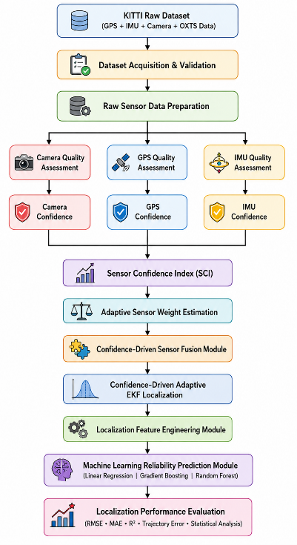
Fig. 1. Overall Architecture of the Proposed Confidence-Driven Adaptive Multi-Sensor Fusion Framework
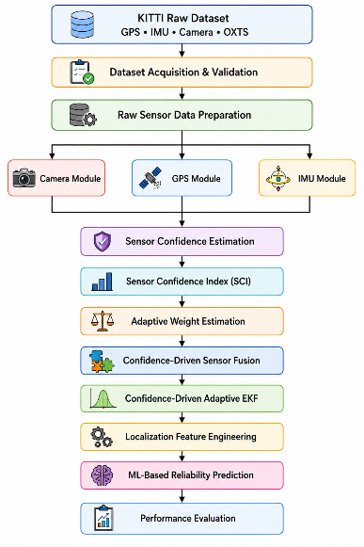
Fig. 2. Data Flow Diagram (DFD Level-0)
3.2 KITTI Dataset Acquisition and Validation
The proposed Confidence-Driven Adaptive Multi-Sensor Fusion Framework utilizes the KITTI Raw Dataset as the primary source of synchronized multimodal sensor measurements for autonomous vehicle localization. The KITTI Raw Dataset was selected because it provides high-quality synchronized observations acquired from multiple heterogeneous sensors under realistic urban, residential, and highway driving environments. The dataset includes calibrated monocular camera images, Global Positioning System (GPS) measurements, Inertial Measurement Unit (IMU) observations, and OXTS navigation data, making it one of the most widely used benchmark datasets for evaluating localization, navigation, sensor fusion, and autonomous driving algorithms.
Unlike synthetic datasets, the KITTI Raw Dataset captures real-world driving scenarios with varying vehicle speeds, road geometries, traffic densities, illumination conditions, and environmental characteristics. These diverse operating conditions naturally introduce variations in sensor performance, making the dataset suitable for evaluating confidence-aware adaptive sensor fusion algorithms. Furthermore, all sensing modalities are accurately time-synchronized and spatially calibrated, enabling reliable integration of heterogeneous sensor measurements.
For this work, synchronized GPS, IMU, camera, and OXTS data are extracted from multiple driving sequences. The OXTS packets provide navigation information including latitude, longitude, altitude, roll, pitch, yaw, linear velocity, angular velocity, acceleration, satellite information, navigation status, and positioning accuracy. These measurements form the primary input for the subsequent sensor quality assessment and confidence estimation stages.
Before confidence estimation and localization, the acquired dataset undergoes a comprehensive validation procedure to ensure that only complete, synchronized, and reliable sensor observations are processed. Since multi-sensor fusion strongly depends on temporal consistency, incomplete or unsynchronized measurements can significantly degrade localization performance. Therefore, dataset validation consists of four sequential stages:
- Dataset Completeness Verification
- Timestamp Synchronization Verification
- Frame Consistency Verification
- Sensor Availability Verification

3.2.1 Dataset Completeness Verification
The first validation stage verifies whether every recorded frame contains valid observations from all required sensing modalities. Missing GPS, IMU, or camera measurements interrupt temporal continuity and reduce the reliability of sensor fusion.
The dataset completeness ratio is defined as
$$\begin{matrix} & C_{dataset}=\frac{N_{valid}}{N_{total}} & & \text{(1)}\end{matrix}$$
where
- $N_{valid}$= Number of valid synchronized frames.
- $N_{total}$= Total number of recorded frames.
A completely valid dataset satisfies
$$\begin{matrix} & C_{dataset}=1 & & \text{(2)}\end{matrix}$$
which indicates that every recorded frame contains GPS, IMU, and camera measurements.

3.2.2 Timestamp Synchronization Verification
Since GPS, IMU, and camera sensors operate at different sampling frequencies, temporal synchronization is essential before performing sensor fusion.
The synchronization error between the sensors is calculated as
$$\begin{matrix} & E_{t}=∣t_{GPS}-t_{IMU}∣+∣t_{GPS}-t_{Cam}∣ & & \text{(3)}\end{matrix}$$
where
- $t_{GPS}$= GPS timestamp
- $t_{IMU}$= IMU timestamp
- $t_{Cam}$= Camera timestamp
A frame is considered synchronized if
$$\begin{matrix} & E_{t}≤ε & & \text{(4)}\end{matrix}$$
where
$ε$denotes the maximum allowable synchronization tolerance.
Frames violating this condition are removed before further processing.

3.2.3 Frame Consistency Verification
After timestamp synchronization, the framework verifies that the number of camera images exactly matches the number of GPS and IMU observations within each driving sequence.
The frame consistency ratio is computed as
$$\begin{matrix} & F_{c}=\frac{N_{matched}}{N_{expected}} & & \text{(5)}\end{matrix}$$
where
- $N_{matched}$= Number of synchronized multimodal frames.
- $N_{expected}$= Expected number of frames in the driving sequence.
Perfect frame consistency is achieved when
$$\begin{matrix} & F_{c}=1 & & \text{(6)}\end{matrix}$$
which indicates that every frame contains synchronized observations from all sensors.

3.2.4 Sensor Availability Verification
The final validation stage verifies the availability of every sensing modality before quality assessment begins.
For the $i^{th}$frame,
$$\begin{matrix} & S_{i}=\left\{\begin{matrix}1, & \text{if GPS, IMU, and Camera data are available} \\ 0, & \text{otherwise}\end{matrix}\right. & & \text{(7)}\end{matrix}$$
Only frames satisfying
$$\begin{matrix} & S_{i}=1 & & \text{(8)}\end{matrix}$$
are forwarded to the sensor quality assessment stage.

Algorithm 1: Dataset Validation
For each frame $i$,
- Check whether GPS data exist.
- Check whether IMU data exist.
- Check whether camera image exists.
- Verify timestamp synchronization.
- Verify frame consistency.
- If all conditions are satisfied,
$$S_{i}=1$$
Otherwise,
$$S_{i}=0$$
Only frames with $S_{i}=1$are used in the proposed framework.

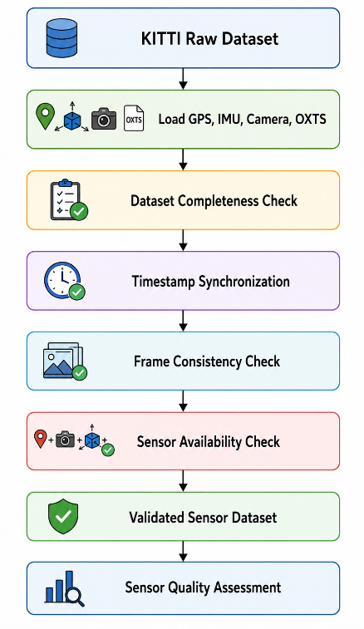
Fig. 3 Dataset Acquisition and Validation Workflow
Table 1 KITTI Dataset Statistics
Driving Sequence | Camera Frames | GPS Frames | IMU Frames | Synchronization | Validation Status
Drive 0001 | 108 | 108 | 108 | Pass | Valid
Drive 0002 | 77 | 77 | 77 | Pass | Valid
Drive 0005 | 154 | 154 | 154 | Pass | Valid
Drive 0009 | 447 | 447 | 447 | Pass | Valid
Drive 0011 | 233 | 233 | 233 | Pass | Valid
Drive 0015 | 297 | 297 | 297 | Pass | Valid
Drive 0018 | 270 | 270 | 270 | Pass | Valid
Drive 0020 | 86 | 86 | 86 | Pass | Valid
Drive 0022 | 800 | 800 | 800 | Pass | Valid
Total | 2472 | 2472 | 2472 | Pass | Validated

3.3 Sensor Quality Assessment
The accuracy and reliability of autonomous vehicle localization depend heavily on the quality of the sensor measurements used during the fusion process. Although GPS receivers, Inertial Measurement Units (IMUs), and cameras provide complementary information about vehicle motion and the surrounding environment, the quality of their measurements varies continuously due to environmental conditions, sensor noise, hardware limitations, vehicle dynamics, and external disturbances. Conventional localization methods typically assume constant sensor reliability or rely on predefined uncertainty parameters throughout vehicle operation. In real-world driving environments, however, these assumptions rarely hold because sensor performance changes over time, often leading to reduced localization accuracy.
To address this challenge, the proposed Confidence-Driven Adaptive Multi-Sensor Fusion Framework incorporates a dedicated Sensor Quality Assessment (SQA) stage before confidence estimation and sensor fusion. Instead of directly fusing raw sensor observations, the framework first evaluates the operational quality of each sensing modality independently. This preliminary assessment enables unreliable measurements to be identified before localization, thereby reducing their influence on the final vehicle state estimation and improving the robustness of the sensor fusion process.
The Sensor Quality Assessment stage consists of three independent quality evaluation modules corresponding to the sensing modalities used in this study: GPS, IMU, and Camera. Since each sensor operates according to different physical principles and is affected by different sources of uncertainty, dedicated quality metrics are designed for each sensing modality. These metrics quantify sensor reliability by analyzing measurable characteristics that directly influence localization performance under real-world driving conditions.
The Camera Quality Assessment module evaluates image reliability using several visual quality metrics, including brightness, contrast, blur level, entropy, edge density, dynamic range, and image noise. Together, these metrics describe the amount of useful visual information available for localization while identifying degraded images caused by poor illumination, motion blur, low-texture scenes, adverse weather conditions, or sensor noise. Images with higher quality scores are expected to provide more reliable visual features for localization.
The GPS Quality Assessment module estimates navigation reliability using indicators such as horizontal positioning accuracy, velocity accuracy, satellite availability, navigation status, and positioning stability. These parameters provide a quantitative measure of satellite signal integrity and positioning reliability under different environmental and satellite visibility conditions. Lower positioning errors and better satellite geometry generally indicate higher GPS reliability.
Similarly, the IMU Quality Assessment module evaluates inertial sensor performance by analyzing acceleration stability, angular velocity stability, motion consistency, and inertial measurement noise. These metrics characterize the dynamic behavior of the IMU and help identify unreliable measurements caused by excessive vehicle dynamics, vibration, sensor drift, or measurement disturbances that may degrade localization accuracy.
Because the extracted quality metrics have different numerical ranges and physical units, all sensor-specific quality indicators are normalized before confidence estimation. This normalization converts heterogeneous measurements into a common numerical scale, enabling direct comparison of sensor quality across different sensing modalities. The normalized quality metrics then serve as the primary inputs for computing the proposed Sensor Confidence Index (SCI), which is described in the following section.
The overall Sensor Quality Assessment workflow adopted in the proposed framework is illustrated in Fig. 4, showing the independent evaluation of camera, GPS, and IMU quality metrics before confidence estimation and adaptive sensor fusion.
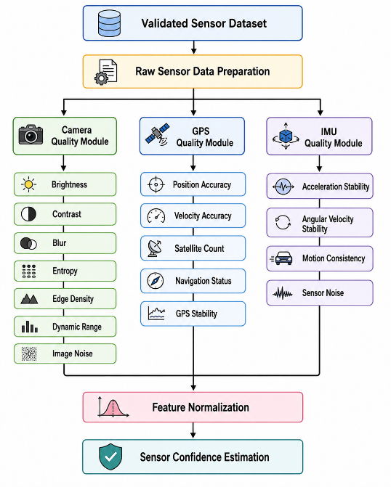
Fig. 4. Overall workflow of the proposed Sensor Quality Assessment module illustrating independent evaluation of camera, GPS, and IMU measurements prior to confidence estimation.
Algorithm 2. Sensor Quality Assessment
Input:
- Validated GPS, IMU, and Camera sensor data
Output:
- Normalized sensor quality metrics
Procedure:
Step 1: Load the validated sensor observations.
Step 2: For each validated frame:
Extract GPS measurements.
Extract IMU measurements.
Extract the camera image.
Step 3: Compute the Camera Quality Metrics.
Step 4: Compute the GPS Quality Metrics.
Step 5: Compute the IMU Quality Metrics.
Step 6: Normalize all sensor quality metrics.
Step 7: Store the normalized sensor quality features.
Step 8: Generate the normalized sensor quality feature set.
Step 9: Return the normalized sensor quality metrics.

3.3.1 Camera Quality Assessment
The camera is one of the primary sensing modalities used in autonomous vehicle localization because it provides rich visual information about the surrounding environment. Camera images play a crucial role in feature extraction, visual odometry, object detection, lane detection, semantic scene understanding, and map-based localization. However, the reliability of visual information is strongly influenced by image quality, which can deteriorate due to variations in illumination, motion blur, adverse weather conditions, sensor noise, shadows, and low-texture environments. Such degradations reduce the number of reliable visual features available for localization and can significantly affect the performance of subsequent sensor fusion and vehicle state estimation algorithms.
To overcome this limitation, the proposed Confidence-Driven Adaptive Multi-Sensor Fusion Framework performs a comprehensive camera quality assessment before confidence estimation and sensor fusion. Rather than assuming that every captured image contributes equally to localization, the framework evaluates the quality of each image using multiple objective image quality measures. These measures, referred to as Camera Quality Metrics (CQMs), provide a quantitative assessment of the visual information available in each image and serve as the basis for estimating camera reliability.
The proposed Camera Quality Assessment module computes seven complementary image quality metrics: Brightness, Contrast, Blur Level, Image Entropy, Edge Density, Dynamic Range, and Image Noise. Each metric captures a different aspect of image quality, and together they provide a comprehensive description of the suitability of an image for localization. High-quality images typically exhibit adequate illumination, balanced contrast, sharp edges, rich texture information, a wide dynamic range, and low noise levels. In contrast, degraded images often contain poor illumination, excessive blur, reduced texture, limited dynamic range, or significant noise, all of which can reduce localization accuracy.
Initially, each validated camera image is converted into a grayscale representation to reduce computational complexity while preserving the structural information required for image quality analysis. Image preprocessing operations, including resizing and filtering, are then applied to improve processing consistency. The preprocessed grayscale image is subsequently analyzed to compute the individual Camera Quality Metrics. Each metric is calculated independently, normalized to a common numerical scale, and stored as part of the camera quality feature vector. These normalized quality features are later integrated into the Sensor Confidence Index (SCI) to estimate the confidence level of the camera sensor during adaptive sensor fusion.
The complete workflow of the proposed Camera Quality Assessment module is illustrated in Fig. 5, showing the sequential stages of image preprocessing, quality metric extraction, feature normalization, and generation of the camera quality feature vector for subsequent confidence estimation.
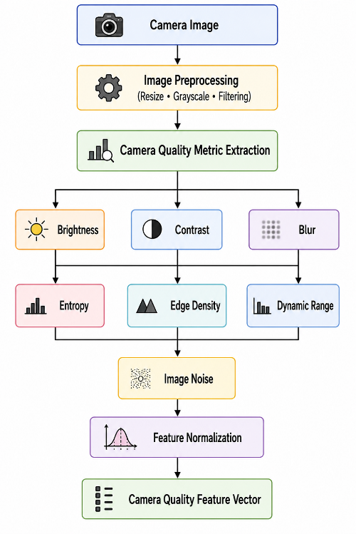
Fig. 5. Workflow of the proposed Camera Quality Assessment module used to extract normalized visual quality metrics for confidence estimation.
3.3.1.1 Brightness Estimation
Brightness represents the average illumination level of an image and indicates whether sufficient lighting is available for reliable feature extraction. Images that are underexposed or overexposed generally contain fewer distinguishable visual features, which can adversely affect localization performance.
The average image brightness is computed as
$$\begin{matrix} & B=\frac{1}{MN}\sum_{x=1}^{M}{\sum_{y=1}^{N}{I(x,y)}} & & \text{(9)}\end{matrix}$$
where
- $I(x,y)$is the grayscale intensity of the pixel located at $\left(x , y\right)$;
- $M$denotes the image height;
- $N$denotes the image width.
Higher brightness values generally indicate better illumination for feature extraction.

3.3.1.2 Contrast Estimation
Image contrast measures the variation in pixel intensities and reflects the visibility of objects and scene details. Images with higher contrast generally provide clearer structural information for localization.
The image contrast is calculated using the standard deviation of grayscale intensities,
$$\begin{matrix} & C=\sqrt{\frac{1}{MN}\sum_{x=1}^{M}{\sum_{y=1}^{N}{{\left(I(x,y)-μ\right)}^{2}}}} & & \text{(10)}\end{matrix}$$
where
$$\begin{matrix} & μ=\frac{1}{MN}\sum_{x=1}^{M}{\sum_{y=1}^{N}{I(x,y)}} & & \text{(11)}\end{matrix}$$
is the mean grayscale intensity of the image.

3.3.1.3 Blur Estimation
Image blur reduces sharpness and decreases the number of reliable visual features available for localization. The proposed framework estimates image blur using the variance of the Laplacian operator.
$$\begin{matrix} & B_{blur}=Var⁡\text{ ⁣}\left(∇^{2}I\right) & & \text{(12)}\end{matrix}$$
where
- $∇^{2}I$represents the Laplacian of the grayscale image.
Higher values of $B_{blur}$indicate sharper images, whereas lower values indicate greater image blur.

3.3.1.4 Image Entropy
Image entropy quantifies the amount of information contained in an image. Images with higher entropy generally contain richer texture and more discriminative visual features.
The entropy is computed as
$$\begin{matrix} & H=-\sum_{i=0}^{255}{p_{i}}{log⁡}_{2}(p_{i}) & & \text{(13)}\end{matrix}$$
where
- $p_{i}$denotes the probability of intensity level $i$.

3.3.1.5 Edge Density
Edge density measures the proportion of pixels corresponding to image edges and represents the structural information available for localization.
It is computed as
$$\begin{matrix} & E_{d}=\frac{N_{edge}}{MN} & & \text{(14)}\end{matrix}$$
where
- $N_{edge}$is the number of detected edge pixels.
Higher edge density generally indicates richer structural information.

3.3.1.6 Dynamic Range
Dynamic range represents the spread between the brightest and darkest regions of an image.
It is calculated as
$$\begin{matrix} & DR=I_{max}-I_{min} & & \text{(15)}\end{matrix}$$
where
- $I_{max}$is the maximum grayscale intensity;
- $I_{min}$is the minimum grayscale intensity.
A larger dynamic range generally indicates better illumination distribution.

3.3.1.7 Image Noise Estimation
Image noise is estimated by comparing the original image with its denoised version. The noise level is computed as the Root Mean Square Error (RMSE) between the two images.
$$\begin{matrix} & N=\sqrt{\frac{1}{MN}\sum_{x=1}^{M}{\sum_{y=1}^{N}{{\left(I(x,y)-\hat{I}(x,y)\right)}^{2}}}} & & \text{(16)}\end{matrix}$$
where
- $I(x,y)$is the original grayscale image;
- $\hat{I}(x,y)$is the denoised image.
Lower noise values indicate better image quality.

Algorithm 3. Camera Quality Assessment
Input:
- Camera image
Output:
- Normalized camera quality metrics
Procedure:
- Read the input camera image.
- Convert the image to grayscale.
- Apply image preprocessing (resizing and filtering).
- Compute the average image brightness.
- Compute the image contrast.
- Estimate the blur level using the variance of the Laplacian.
- Compute the image entropy.
- Compute the edge density.
- Compute the dynamic range.
- Estimate the image noise.
- Normalize all camera quality metrics.
- Generate the camera quality feature vector.
- Return the normalized camera quality metrics.

Table 2. Camera Quality Metrics
Metric | Description | Purpose
Brightness | Average grayscale intensity | Evaluates illumination quality
Contrast | Standard deviation of pixel intensities | Measures visual distinguishability
Blur Level | Variance of the Laplacian operator | Estimates image sharpness
Image Entropy | Information content of the image | Quantifies scene complexity
Edge Density | Ratio of detected edge pixels | Measures structural information
Dynamic Range | Difference between maximum and minimum intensity | Evaluates illumination distribution
Image Noise | RMSE between original and denoised images | Measures sensor and imaging noise

3.3.2 GPS Quality Assessment
The Global Positioning System (GPS) is one of the primary sensing modalities used for autonomous vehicle localization because it provides absolute position, velocity, and navigation information within a global reference frame. Unlike relative localization sensors, GPS enables a vehicle to estimate its geographic location independently of previous states, making it an essential component of modern autonomous navigation systems. However, the accuracy and reliability of GPS measurements are strongly influenced by several external factors, including satellite geometry, signal blockage, multipath propagation, atmospheric disturbances, urban canyon effects, and electromagnetic interference. These factors introduce measurement uncertainty that can significantly degrade localization performance.
Conventional localization systems generally utilize raw GPS observations directly during sensor fusion without explicitly evaluating their quality beforehand. As a result, unreliable or degraded GPS measurements may contribute equally to the localization process, potentially increasing positioning errors and reducing overall localization robustness. To overcome this limitation, the proposed Confidence-Driven Adaptive Multi-Sensor Fusion Framework incorporates a dedicated GPS Quality Assessment (GQA) module that quantitatively evaluates the reliability of GPS measurements before confidence estimation and sensor fusion.
The proposed GPS Quality Assessment module extracts multiple navigation quality indicators directly from the OXTS navigation packets provided in the KITTI Raw Dataset. These indicators capture different aspects of GPS measurement reliability and collectively provide a comprehensive assessment of navigation quality under varying operating conditions. Specifically, the framework evaluates Position Accuracy, Velocity Accuracy, Satellite Availability, Navigation Status, and GPS Position Stability. Together, these metrics characterize the integrity, consistency, and reliability of GPS observations used for vehicle localization.
Initially, the validated GPS observations are extracted from the synchronized OXTS data and preprocessed to remove invalid or inconsistent measurements. The selected GPS quality indicators are then computed independently for each localization frame. Since these indicators have different physical units and numerical ranges, each metric is normalized to a common scale before further processing. The normalized GPS quality metrics are subsequently combined into a GPS quality feature vector, which serves as the input to the Sensor Confidence Estimation module for computing the Sensor Confidence Index (SCI).
By evaluating GPS measurement quality before sensor fusion, the proposed framework reduces the influence of unreliable satellite observations and improves the robustness of confidence-aware localization, particularly in challenging environments where GPS performance may vary significantly.
The complete workflow of the proposed GPS Quality Assessment module is illustrated in Fig. 6, showing the sequential stages of GPS data extraction, quality metric computation, feature normalization, and generation of the GPS quality feature vector for subsequent confidence estimation.
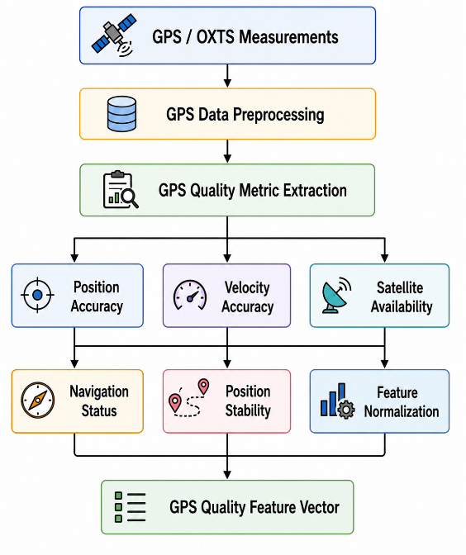
Fig. 6. Workflow of the proposed GPS Quality Assessment module for extracting normalized GPS quality metrics.
3.3.2.1 Position Accuracy
Position accuracy represents the estimated uncertainty associated with the GPS position measurement. Lower positioning uncertainty corresponds to higher localization reliability, whereas larger uncertainty indicates degraded satellite positioning performance.
The normalized position quality is computed as
$$\begin{matrix} & Q_{pos}=\frac{1}{1+PA} & & \text{(17)}\end{matrix}$$
where
- $PA$denotes the GPS position accuracy (m) reported by the GPS navigation system.
Higher values of $Q_{pos}$indicate better positioning quality.

3.3.2.2 Velocity Accuracy
Velocity accuracy evaluates the uncertainty associated with GPS velocity estimation. Accurate velocity measurements contribute significantly to reliable vehicle localization and motion estimation.
The normalized velocity quality is calculated as
$$\begin{matrix} & Q_{vel}=\frac{1}{1+VA} & & \text{(18)}\end{matrix}$$
where
- $VA$represents the GPS velocity accuracy (m/s).
Lower velocity uncertainty results in higher velocity quality.

3.3.2.3 Satellite Availability
The number of visible satellites directly influences GPS positioning accuracy and navigation reliability. Greater satellite availability generally improves satellite geometry and reduces localization uncertainty.
The satellite availability quality is computed as
$$\begin{matrix} & Q_{sat}=\frac{N_{sat}}{N_{max}} & & \text{(19)}\end{matrix}$$
where
- $N_{sat}$is the number of visible satellites.
- $N_{max}$is the maximum expected satellite count.
The resulting quality score is normalized between 0 and 1.

3.3.2.4 Navigation Status
Navigation status represents the operational mode of the GPS receiver and indicates whether a valid navigation solution is available.
The navigation status quality is defined as
$$\begin{matrix} & Q_{nav}=\left\{\begin{matrix}1, & \text{Reliable navigation solution} \\ 0, & \text{Unavailable or invalid navigation solution}\end{matrix}\right. & & \text{(20)}\end{matrix}$$
Reliable navigation solutions receive the highest confidence score, whereas invalid navigation states receive the lowest confidence.

3.3.2.5 GPS Position Stability
GPS position stability measures the consistency of consecutive GPS position estimates over time. Large variations between successive measurements generally indicate degraded positioning performance or unstable satellite observations.
The normalized position stability is computed as
$$\begin{matrix} & Q_{stab}=\frac{1}{1+ΔP} & & \text{(21)}\end{matrix}$$
where
$$\begin{matrix} & ΔP=\sqrt{{\left(x_{t}-x_{t-1})^{2}+(y_{t}-y_{t-1}\right)}^{2}} & & \text{(22)}\end{matrix}$$
is the Euclidean distance between two consecutive GPS position estimates.
Here,
- $x_{t},y_{t}$denote the current GPS position.
- $x_{t-1},y_{t-1}$denote the previous GPS position.
Smaller positional variations correspond to higher GPS measurement stability.

3.3.2.6 GPS Confidence Score
After computing the individual GPS quality metrics, they are combined to obtain an overall GPS Confidence Score, which represents the reliability of the GPS sensor for the current localization frame. This confidence score summarizes the overall quality of the GPS observations and serves as the GPS contribution to the Sensor Confidence Index (SCI) used in the proposed adaptive sensor fusion framework.
The GPS Confidence Score is computed as
$$\begin{matrix} & C_{GPS}=w_{1}Q_{pos}+w_{2}Q_{vel}+w_{3}Q_{sat}+w_{4}Q_{nav}+w_{5}Q_{stab} & & \text{(23)}\end{matrix}$$
subject to
$$\begin{matrix} & \sum_{i=1}^{5}{w_{i}}=1,w_{i}≥0 & & \text{(24)}\end{matrix}$$
where
- $Q_{pos}$is the Position Accuracy quality score.
- $Q_{vel}$is the Velocity Accuracy quality score.
- $Q_{sat}$is the Satellite Availability quality score.
- $Q_{nav}$is the Navigation Status quality score.
- $Q_{stab}$is the GPS Position Stability quality score.
- $w_{i}$denotes the weighting coefficient assigned to each quality metric.
In this work, equal weighting is adopted for all GPS quality metrics due to their complementary contribution to GPS reliability. Therefore,
$$\begin{matrix} & w_{1}=w_{2}=w_{3}=w_{4}=w_{5}=0.2 & & \text{(25)}\end{matrix}$$
The resulting GPS Confidence Score is normalized within the range
$$\begin{matrix} & 0≤C_{GPS}≤1 & & \text{(26)}\end{matrix}$$
where values close to 1 indicate highly reliable GPS observations, whereas values approaching 0 indicate poor GPS quality. The computed GPS Confidence Score is subsequently forwarded to the Sensor Confidence Estimation module, where it is integrated with the confidence scores of the IMU and camera sensors to compute the overall Sensor Confidence Index (SCI).

Algorithm 4. GPS Quality Assessment
Input:
- GPS and OXTS measurements
Output:
- GPS confidence score and normalized GPS quality metrics
Procedure:
- Load the synchronized GPS and OXTS measurements.
- Extract the GPS navigation parameters.
- Compute the Position Accuracy quality score.
- Compute the Velocity Accuracy quality score.
- Compute the Satellite Availability quality score.
- Evaluate the Navigation Status quality score.
- Compute the GPS Position Stability quality score.
- Normalize all GPS quality metrics.
- Compute the GPS Confidence Score using Eq. (23).
- Generate the GPS quality feature vector.
- Return the GPS Confidence Score and normalized GPS quality metrics.

Table 3. GPS Quality Metrics
Quality Metric | Description | Purpose
Position Accuracy | GPS positioning uncertainty | Evaluates localization precision
Velocity Accuracy | GPS velocity uncertainty | Evaluates motion estimation reliability
Satellite Availability | Number of visible satellites | Measures satellite signal availability
Navigation Status | GPS receiver operational mode | Indicates navigation reliability
Position Stability | Consistency of consecutive GPS positions | Measures GPS measurement stability
GPS Confidence Score | Weighted combination of normalized GPS quality metrics | Provides an overall confidence estimate of GPS reliability for adaptive sensor fusion

3.3.3 IMU Quality Assessment
The Inertial Measurement Unit (IMU) is a fundamental sensing modality for autonomous vehicle localization because it continuously measures the vehicle's linear acceleration and angular velocity. Unlike GPS, which provides absolute position information, the IMU estimates the vehicle's motion by monitoring changes in acceleration and rotational dynamics over time. Owing to its high sampling frequency, the IMU can accurately capture rapid vehicle movements and provide continuous motion information even during temporary GPS degradation or signal loss. Consequently, IMU measurements play a vital role in estimating vehicle orientation, velocity, and trajectory, making them an indispensable component of multi-sensor localization systems.
Despite these advantages, IMU measurements are affected by several error sources, including sensor bias, thermal drift, vibration, measurement noise, scale-factor errors, and cumulative integration drift. These errors gradually accumulate over time and can significantly reduce localization accuracy if unreliable inertial measurements are directly incorporated into the sensor fusion process. Therefore, evaluating the quality and reliability of IMU measurements prior to confidence estimation is essential for achieving robust and accurate vehicle localization.
To overcome these limitations, the proposed Confidence-Driven Adaptive Multi-Sensor Fusion Framework incorporates a dedicated IMU Quality Assessment (IQA) module that quantitatively evaluates the reliability of inertial measurements before sensor fusion. Rather than treating all IMU observations equally, the framework computes multiple motion-related quality indicators that characterize the stability, consistency, and noise characteristics of the inertial sensor. These quality indicators collectively provide a comprehensive assessment of IMU reliability under varying vehicle dynamics and environmental conditions.
The proposed IMU Quality Assessment module evaluates four complementary quality metrics: Acceleration Stability, Angular Velocity Stability, Motion Consistency, and IMU Noise Level. These metrics describe different aspects of inertial sensor performance and collectively determine the suitability of IMU measurements for localization. Stable acceleration and angular velocity measurements, consistent vehicle motion, and low sensor noise generally indicate reliable inertial observations, whereas excessive fluctuations, drift, or noise suggest degraded measurement quality.
Initially, the validated IMU observations are extracted from the synchronized OXTS data and preprocessed to remove invalid or inconsistent measurements. The selected IMU quality metrics are then computed independently for each localization frame. Since these metrics possess different physical units and numerical ranges, each quality metric is normalized to a common scale before further processing. The normalized IMU quality metrics are subsequently combined to generate an IMU Confidence Score, which represents the overall reliability of the inertial sensor. This confidence score is later integrated with the GPS and camera confidence scores during the computation of the Sensor Confidence Index (SCI) for confidence-driven adaptive sensor fusion.
The complete workflow of the proposed IMU Quality Assessment module is illustrated in Fig. 7, showing the sequential stages of IMU data extraction, quality metric computation, feature normalization, confidence score generation, and preparation of the IMU quality feature vector for subsequent Sensor Confidence Estimation.
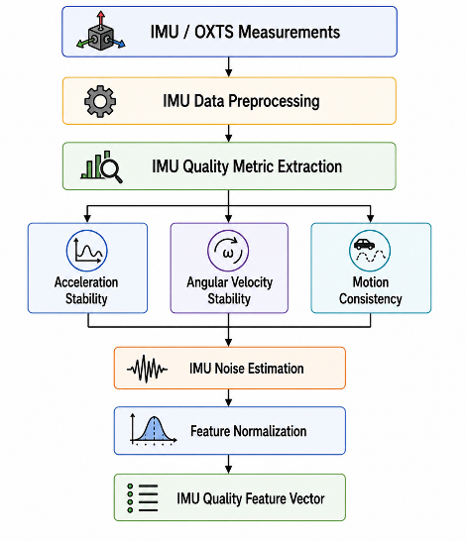
Fig. 7. Workflow of the proposed IMU Quality Assessment module for extracting normalized inertial quality metrics.
3.3.3.1 Acceleration Stability
Acceleration stability measures the consistency of the linear acceleration measurements obtained from the IMU. Stable acceleration values indicate smooth vehicle motion and reliable inertial observations, whereas large fluctuations generally correspond to abrupt vehicle maneuvers or measurement disturbances.
The normalized acceleration stability is computed as
$$\begin{matrix} & Q_{acc}=\frac{1}{1+σ_{a}} & & \text{(27)}\end{matrix}$$
where
- $σ_{a}$is the standard deviation of the linear acceleration measurements.
Higher values of $Q_{acc}$indicate more stable acceleration measurements.

3.3.3.2 Angular Velocity Stability
Angular velocity stability evaluates the consistency of gyroscope measurements obtained from the IMU. Reliable angular velocity measurements are essential for accurate vehicle orientation estimation.
The normalized angular velocity stability is calculated as
$$\begin{matrix} & Q_{gyro}=\frac{1}{1+σ_{ω}} & & \text{(28)}\end{matrix}$$
where
- $σ_{ω}$denotes the standard deviation of the angular velocity measurements.
Lower angular velocity variations result in higher quality scores.

3.3.3.3 Motion Consistency
Motion consistency evaluates the agreement between consecutive inertial measurements and reflects the smoothness of the estimated vehicle motion. Consistent motion indicates stable vehicle dynamics and reliable inertial observations.
The normalized motion consistency is computed as
$$\begin{matrix} & Q_{motion}=\frac{1}{1+ΔM} & & \text{(29)}\end{matrix}$$
where
$$\begin{matrix} & ΔM=\sqrt{{\left(a_{t} − a_{t-1}\right)}^{2}+{\left(ω_{t} − ω_{t-1}\right)}^{2}} & & \text{(30)}\end{matrix}$$
Here,
- $a_{t}$and $a_{t-1}$denote the current and previous linear acceleration measurements.
- $ω_{t}$and $ω_{t-1}$denote the current and previous angular velocity measurements.
Smaller motion variations correspond to higher motion consistency.

3.3.3.4 IMU Noise Level
The IMU noise level is estimated from the variability of inertial measurements over a short observation window. Lower noise levels indicate more reliable sensor measurements.
The normalized IMU noise quality is computed as
$$\begin{matrix} & Q_{noise}=\frac{1}{1+σ_{n}} & & \text{(31)}\end{matrix}$$
where
- $σ_{n}$represents the estimated IMU noise level.
Higher values of $Q_{noise}$indicate lower sensor noise and improved measurement reliability.

3.3.3.5 IMU Confidence Score
After computing the individual IMU quality metrics, they are combined to obtain an overall IMU Confidence Score, which represents the reliability of the inertial sensor for the current localization frame. This confidence score summarizes the overall quality of the IMU observations and serves as the IMU contribution to the Sensor Confidence Index (SCI) used in the proposed confidence-driven adaptive sensor fusion framework.
The IMU Confidence Score is computed as
$$\begin{matrix} & C_{IMU}=w_{1}Q_{acc}+w_{2}Q_{gyro}+w_{3}Q_{motion}+w_{4}Q_{noise} & & \text{(32)}\end{matrix}$$
subject to
$$\begin{matrix} & \sum_{i=1}^{4}{w_{i}}=1,w_{i}≥0 & & \text{(33)}\end{matrix}$$
where
- $Q_{acc}$is the Acceleration Stability quality score.
- $Q_{gyro}$is the Angular Velocity Stability quality score.
- $Q_{motion}$is the Motion Consistency quality score.
- $Q_{noise}$is the IMU Noise Level quality score.
- $w_{i}$denotes the weighting coefficient assigned to each IMU quality metric.
In this work, equal weighting is adopted for all IMU quality metrics due to their complementary contribution to inertial sensor reliability. Therefore,
$$\begin{matrix} & w_{1}=w_{2}=w_{3}=w_{4}=0.25 & & \text{(34)}\end{matrix}$$
The resulting IMU Confidence Score is normalized within the range
$$\begin{matrix} & 0≤C_{IMU}≤1 & & \text{(35)}\end{matrix}$$
where values close to 1 indicate highly reliable IMU observations, whereas values approaching 0 indicate degraded inertial measurements. The computed IMU Confidence Score is subsequently forwarded to the Sensor Confidence Estimation module, where it is integrated with the GPS and camera confidence scores to compute the overall Sensor Confidence Index (SCI).

Algorithm 5. IMU Quality Assessment
Input:
- IMU and OXTS measurements
Output:
- IMU confidence score and normalized IMU quality metrics
Procedure:
- Load the synchronized IMU and OXTS measurements.
- Extract the linear acceleration and angular velocity observations.
- Compute the Acceleration Stability quality score.
- Compute the Angular Velocity Stability quality score.
- Compute the Motion Consistency quality score.
- Compute the IMU Noise Level quality score.
- Normalize all IMU quality metrics.
- Compute the IMU Confidence Score using Eq. (32).
- Generate the IMU quality feature vector.
- Return the IMU Confidence Score and normalized IMU quality metrics.

Table 4. IMU Quality Metrics
Quality Metric | Description | Purpose
Acceleration Stability | Stability of linear acceleration measurements | Evaluates inertial motion consistency
Angular Velocity Stability | Stability of gyroscope measurements | Assesses orientation estimation reliability
Motion Consistency | Consistency between consecutive IMU observations | Measures motion continuity
IMU Noise Level | Estimated inertial sensor noise | Evaluates measurement quality
IMU Confidence Score | Weighted combination of normalized IMU quality metrics | Represents the overall reliability of IMU observations for adaptive sensor fusion

3.4 Sensor Confidence Index (SCI)
The Camera, GPS, and IMU Quality Assessment modules independently estimate the reliability of their respective sensor measurements by computing the Camera Confidence Score $\left(C_{Cam}\right)$, GPS Confidence Score $\left(C_{GPS}\right)$, and IMU Confidence Score $\left(C_{IMU}\right)$. Although these confidence scores effectively characterize the quality of individual sensing modalities, autonomous vehicle localization requires a unified confidence representation that reflects the collective reliability of all available sensors. To address this requirement, the proposed framework introduces the Sensor Confidence Index (SCI), which integrates the confidence scores of the camera, GPS, and IMU into a single normalized confidence measure.
Unlike conventional multi-sensor localization approaches that rely on fixed sensor reliability assumptions throughout vehicle operation, the proposed SCI continuously summarizes the overall sensing reliability according to the current operating conditions. As sensor quality varies due to illumination changes, satellite visibility, sensor degradation, vehicle dynamics, environmental disturbances, and measurement noise, the SCI is updated accordingly to provide a dynamic and quantitative representation of the overall sensing environment for each localization frame.
The proposed SCI serves as the central confidence indicator of the Confidence-Driven Adaptive Multi-Sensor Fusion Framework. Rather than relying on the confidence of a single sensing modality, it integrates complementary confidence information from the camera, GPS, and IMU to estimate the overall trustworthiness of the available sensor observations. This unified confidence representation establishes a common reliability measure that enables consistent comparison across heterogeneous sensing modalities despite their different physical characteristics and measurement units.
The computed Sensor Confidence Index (SCI) is subsequently forwarded to the Adaptive Weight Estimation (AWE) module, where it is utilized as the global confidence indicator for determining the adaptive contribution of each sensing modality during sensor fusion. Consequently, sensors operating under higher-confidence conditions exert greater influence on the localization process, while the contribution of degraded sensors is proportionally reduced, thereby improving localization robustness, accuracy, and resilience under diverse real-world driving scenarios.
The complete workflow of the proposed Sensor Confidence Index (SCI) computation is illustrated in Fig. 8, showing the integration of the Camera, GPS, and IMU confidence scores into a unified confidence representation prior to adaptive weight estimation.
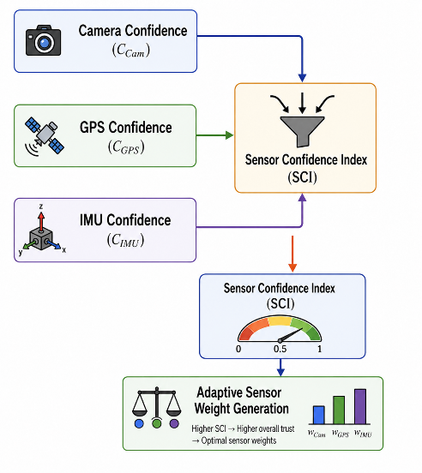
Fig. 8. Computation of the proposed Sensor Confidence Index (SCI) from the individual sensor confidence scores.
3.4.1 Sensor Confidence Index Formulation
The Sensor Confidence Index (SCI) provides a unified representation of the overall reliability of the available sensing modalities for each localization frame. It integrates the normalized confidence scores of the camera, GPS, and IMU into a single confidence measure that reflects the current sensing conditions. Since all sensor confidence scores are normalized within the interval $\left[0 , 1\right]$, they can be directly combined using a weighted linear model.
The proposed Sensor Confidence Index is computed as
$$\begin{matrix} & SCI=αC_{Cam}+βC_{GPS}+γC_{IMU} & & \text{(36)}\end{matrix}$$
subject to
$$\begin{matrix} & α+β+γ=1 & & \text{(37)}\end{matrix} \\ \begin{matrix} & α,β,γ≥0 & & \text{(38)}\end{matrix}$$
where
- $C_{Cam}$is the Camera Confidence Score;
- $C_{GPS}$is the GPS Confidence Score;
- $C_{IMU}$is the IMU Confidence Score;
- $α$, $β$, and $γ$are the weighting coefficients assigned to the camera, GPS, and IMU confidence scores, respectively.
The objective of the Sensor Confidence Index is to provide an unbiased estimate of the overall sensing reliability rather than to determine the contribution of individual sensors during fusion. Therefore, equal weighting is adopted during SCI computation, while the adaptive sensor weights are determined separately in the subsequent Adaptive Weight Estimation (AWE) module. Accordingly,
$$\begin{matrix} & α=β=γ=\frac{1}{3} & & \text{(39)}\end{matrix}$$
The resulting Sensor Confidence Index is constrained within the normalized interval
$$\begin{matrix} & 0≤SCI≤1 & & \text{(40)}\end{matrix}$$
where values close to 1 indicate highly reliable sensing conditions, whereas values approaching 0 indicate degraded sensor observations.
The computed SCI is subsequently forwarded to the Adaptive Weight Estimation (AWE) module, where it serves as a global confidence indicator for generating adaptive sensor weights prior to confidence-driven sensor fusion.
3.4.2 Interpretation of the Sensor Confidence Index
The computed Sensor Confidence Index (SCI) is interpreted as a quantitative indicator of the overall reliability of the sensing environment. It summarizes the collective confidence of the camera, GPS, and IMU sensors and enables the proposed framework to distinguish between reliable and degraded sensing conditions.
Higher SCI values indicate that the available sensor observations exhibit consistently high confidence and are well suited for localization. Conversely, lower SCI values indicate increased uncertainty caused by environmental disturbances, satellite degradation, illumination changes, sensor noise, or vehicle dynamics. The SCI therefore provides a global measure of sensing reliability that guides the Adaptive Weight Estimation module in determining the relative contribution of each sensing modality during localization.
The interpretation adopted in this work is summarized in Table 5.
Table 5. Interpretation of the Sensor Confidence Index
SCI Range | Confidence Level | Localization Reliability
0.80–1.00 | Very High | Highly reliable localization
0.60–0.79 | High | Reliable localization
0.40–0.59 | Moderate | Moderate localization reliability
0.20–0.39 | Low | Reduced localization reliability
0.00–0.19 | Very Low | Poor localization reliability

Algorithm 6. Sensor Confidence Index Computation
Input
- Camera Confidence Score $\left(C_{Cam}\right)$
- GPS Confidence Score $\left(C_{GPS}\right)$
- IMU Confidence Score $\left(C_{IMU}\right)$
Output
- Sensor Confidence Index (SCI)
Procedure
- Load the Camera Confidence Score.
- Load the GPS Confidence Score.
- Load the IMU Confidence Score.
- Assign the equal weighting coefficients $\left(α , β , γ\right)$.
- Compute the Sensor Confidence Index using Eq. (36).
- Verify that the computed SCI satisfies $0≤SCI≤1$.
- Forward the SCI to the Adaptive Weight Estimation (AWE) module.
- Return the Sensor Confidence Index.

3.5 Adaptive Weight Estimation (AWE)
The Sensor Confidence Index (SCI) provides a quantitative measure of the overall reliability of the sensing environment by integrating the confidence scores of the camera, GPS, and IMU sensors into a unified confidence representation. Although the SCI effectively summarizes the global sensing reliability, it does not directly determine the contribution of individual sensing modalities during the sensor fusion process. Therefore, the proposed framework introduces an Adaptive Weight Estimation (AWE) module that dynamically computes the fusion weight assigned to each sensor according to its current confidence and the overall sensing reliability represented by the SCI.
Unlike conventional multi-sensor fusion approaches that employ fixed sensor weights throughout vehicle operation, the proposed AWE module continuously updates the sensor weights for every localization frame. Consequently, sensing modalities exhibiting higher confidence receive proportionally larger fusion weights, whereas sensors affected by measurement degradation are automatically assigned lower weights. This adaptive weighting strategy enables the localization framework to respond effectively to changing environmental conditions, including illumination variations, satellite visibility, adverse weather, sensor degradation, vehicle dynamics, and measurement noise.
The Adaptive Weight Estimation module receives the Camera Confidence Score $\left(C_{Cam}\right)$, GPS Confidence Score $\left(C_{GPS}\right)$, IMU Confidence Score $\left(C_{IMU}\right)$, and the Sensor Confidence Index (SCI) as its inputs. These confidence measures are jointly analyzed to determine the relative contribution of each sensing modality while ensuring that the resulting sensor weights remain normalized and suitable for subsequent confidence-driven sensor fusion. As a result, the proposed framework automatically prioritizes reliable sensors while reducing the influence of degraded measurements, thereby improving localization robustness and estimation accuracy under diverse operating conditions.
The adaptive sensor weights generated by the AWE module are subsequently forwarded to the Confidence-Driven Adaptive Sensor Fusion module, where they are incorporated into the Adaptive Extended Kalman Filter (AEKF) to dynamically regulate the influence of each sensing modality during state estimation.
The complete workflow of the proposed Adaptive Weight Estimation (AWE) module is illustrated in Fig. 9, showing the generation of normalized adaptive sensor weights from the individual sensor confidence scores and the Sensor Confidence Index prior to confidence-driven sensor fusion.
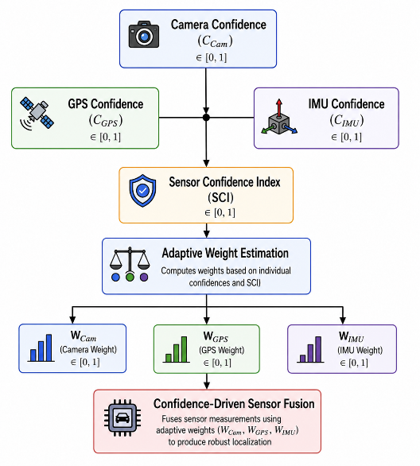
Fig. 9. Workflow of the proposed Adaptive Weight Estimation module.
3.5.1 Adaptive Weight Computation
The Adaptive Weight Estimation (AWE) module determines the contribution of each sensing modality by jointly considering the individual sensor confidence scores and the overall sensing reliability represented by the Sensor Confidence Index (SCI). The individual confidence scores determine the relative importance of each sensing modality, while the SCI modulates the overall confidence assigned to the sensor weighting process.
First, the preliminary sensor weights are computed from the normalized confidence scores as
$$\begin{matrix} & {\tilde{W}}_{Cam}=\frac{C_{Cam}}{C_{Cam}+C_{GPS}+C_{IMU}} & & \text{(41)}\end{matrix} \\ \begin{matrix} & {\tilde{W}}_{GPS}=\frac{C_{GPS}}{C_{Cam}+C_{GPS}+C_{IMU}} & & \text{(42)}\end{matrix} \\ \begin{matrix} & {\tilde{W}}_{IMU}=\frac{C_{IMU}}{C_{Cam}+C_{GPS}+C_{IMU}} & & \text{(43)}\end{matrix}$$
where
- $C_{Cam}$is the Camera Confidence Score;
- $C_{GPS}$is the GPS Confidence Score;
- $C_{IMU}$is the IMU Confidence Score.
The preliminary weights satisfy
$$\begin{matrix} & {\tilde{W}}_{Cam}+{\tilde{W}}_{GPS}+{\tilde{W}}_{IMU}=1. & & \text{(44)}\end{matrix}$$
The overall sensing reliability is then incorporated using the Sensor Confidence Index. The final adaptive sensor weights are obtained as
$$\begin{matrix} & W_{Cam}=SCI⋅{\tilde{W}}_{Cam}+(1-SCI)\frac{1}{3} & & \text{(45)}\end{matrix} \\ \begin{matrix} & W_{GPS}=SCI⋅{\tilde{W}}_{GPS}+(1-SCI)\frac{1}{3} & & \text{(46)}\end{matrix} \\ \begin{matrix} & W_{IMU}=SCI⋅{\tilde{W}}_{IMU}+(1-SCI)\frac{1}{3} & & \text{(47)}\end{matrix}$$
This formulation satisfies
$$\begin{matrix} & W_{Cam}+W_{GPS}+W_{IMU}=1. & & \text{(48)}\end{matrix}$$
When the SCI is close to 1, the adaptive weights are primarily determined by the individual sensor confidence scores. Conversely, when the SCI decreases, the weights gradually move toward an equal distribution, thereby preventing unreliable confidence estimates from disproportionately influencing the sensor fusion process.
3.5.2 Weight Interpretation
The adaptive sensor weights quantify the relative contribution of each sensing modality during confidence-driven sensor fusion. Sensors with higher confidence receive larger weights and exert greater influence on the localization process, whereas degraded sensors are automatically assigned lower weights.
Because the adaptive weights are normalized, they satisfy
$$\begin{matrix} & 0≤W_{i}≤1,\sum_{i}{W_{i}}=1. & & \text{(49)}\end{matrix}$$
The normalized adaptive weights are subsequently supplied to the Confidence-Driven Adaptive Sensor Fusion module, where they are incorporated into the Adaptive Extended Kalman Filter (AEKF) to regulate the contribution of each sensing modality during state estimation.
Algorithm 7. Adaptive Weight Estimation
Input
- Sensor Confidence Index (SCI)
- Camera Confidence Score $\left(C_{Cam}\right)$
- GPS Confidence Score $\left(C_{GPS}\right)$
- IMU Confidence Score $\left(C_{IMU}\right)$
Output
- Adaptive sensor weights
Procedure
- Load the Sensor Confidence Index.
- Load the Camera Confidence Score.
- Load the GPS Confidence Score.
- Load the IMU Confidence Score.
- Compute the preliminary camera weight using Eq. (41).
- Compute the preliminary GPS weight using Eq. (42).
- Compute the preliminary IMU weight using Eq. (43).
- Compute the final adaptive weights using Eqs. (45)–(47).
- Verify that the adaptive weights satisfy Eq. (48).
- Return the adaptive sensor weights.

Table 6. Adaptive Sensor Weights
Weight | Description | Purpose
$$W_{Cam}$$ | Adaptive camera weight | Determines the camera contribution during sensor fusion
$$W_{GPS}$$ | Adaptive GPS weight | Determines the GPS contribution during sensor fusion
$$W_{IMU}$$ | Adaptive IMU weight | Determines the IMU contribution during sensor fusion

3.7 Confidence-Driven Adaptive Extended Kalman Filter (AEKF)
The Confidence-Driven Sensor Fusion (CDSF) module generates a robust localization measurement by integrating observations from the Camera, GPS, and IMU sensors using the adaptive sensor weights obtained from the Adaptive Weight Estimation (AWE) module. Although the fused measurement significantly improves localization reliability, it may still be affected by nonlinear system dynamics, sensor noise, and measurement uncertainties encountered during real-world autonomous vehicle operation. Therefore, the proposed framework employs a Confidence-Driven Adaptive Extended Kalman Filter (AEKF) to recursively estimate the optimal vehicle state while explicitly accounting for these uncertainties.
Unlike the conventional Extended Kalman Filter (EKF), which assumes fixed process and measurement noise covariance matrices throughout the localization process, the proposed AEKF dynamically adjusts the measurement noise covariance according to both the Sensor Confidence Index (SCI) and the adaptive sensor weights generated in the preceding stages. The adaptive sensor weights quantify the relative reliability of individual sensing modalities, while the SCI provides a global measure of the overall sensing environment. By jointly incorporating these confidence measures, the proposed filter continuously adapts the measurement uncertainty to reflect the current sensing conditions.
When the SCI is high and the adaptive sensor weights indicate reliable sensor observations, the filter assigns greater confidence to the fused localization measurements by reducing the adaptive measurement covariance. Conversely, when the SCI decreases because of sensor degradation, environmental disturbances, adverse weather conditions, or poor sensing quality, the adaptive measurement covariance increases, causing the filter to rely more heavily on the prediction model while reducing the influence of uncertain observations. This confidence-driven estimation strategy improves localization stability, minimizes the impact of unreliable measurements, and enhances robustness under diverse real-world operating environments.
The complete workflow of the proposed Confidence-Driven Adaptive Extended Kalman Filter (AEKF) is illustrated in Fig. 10, showing the recursive state prediction, confidence-driven measurement update, adaptive covariance computation, and final vehicle state estimation.
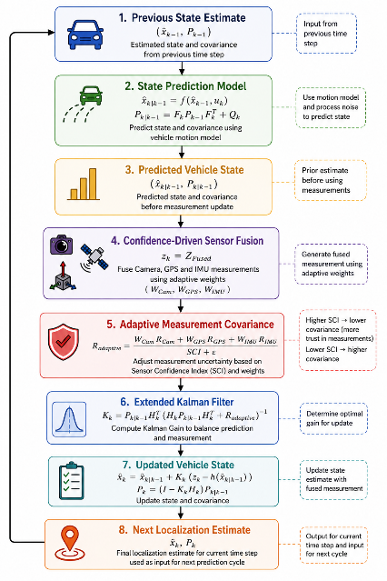
Fig. 10. Workflow of the proposed Confidence-Driven Adaptive Extended Kalman Filter.
3.7.1 State Prediction
During the prediction stage, the vehicle state is propagated using the nonlinear vehicle motion model. This stage estimates the vehicle state at the current time step based on the previous state estimate and the control input before incorporating the fused sensor observations.
The predicted state vector is computed as
$$\begin{matrix} & x_{k∣k-1}=f(x_{k-1},u_{k}) & & \text{(52)}\end{matrix}$$
where
- $x_{k∣k-1}$denotes the predicted vehicle state vector;
- $x_{k-1}$represents the previous estimated state vector;
- $u_{k}$is the control input vector;
- $f(⋅)$denotes the nonlinear vehicle motion model.
The corresponding predicted error covariance matrix is computed as
$$\begin{matrix} & P_{k∣k-1}=F_{k}P_{k-1}F_{k}^{T}+Q_{k} & & \text{(53)}\end{matrix}$$
where
- $F_{k}$is the Jacobian matrix of the nonlinear state transition model;
- $P_{k-1}$denotes the previous error covariance matrix;
- $Q_{k}$represents the process noise covariance matrix.
The predicted state and covariance matrix provide the prior estimate that is subsequently refined using the confidence-driven fused localization measurements.
3.7.2 Adaptive Measurement Covariance
The fused localization measurement generated by the Confidence-Driven Sensor Fusion (CDSF) module is used as the observation input of the proposed Adaptive Extended Kalman Filter (AEKF).
$$\begin{matrix} & z_{k}=Z_{Fused} & & \text{(54)}\end{matrix}$$
Unlike conventional Extended Kalman Filters that employ a fixed measurement noise covariance matrix throughout the localization process, the proposed framework dynamically adjusts the measurement covariance according to both the Adaptive Weight Estimation (AWE) module and the Sensor Confidence Index (SCI).
The adaptive sensor weights quantify the relative reliability of the Camera, GPS, and IMU measurements, while the SCI represents the overall confidence of the sensing environment. By jointly incorporating these confidence measures, the proposed AEKF continuously adapts the measurement uncertainty according to the current sensing conditions.
The adaptive measurement covariance matrix is computed as
$$\begin{matrix} & R_{adaptive}=\frac{W_{Cam}R_{Cam}+W_{GPS}R_{GPS}+W_{IMU}R_{IMU}}{SCI+ε} & & \text{(55)}\end{matrix}$$
where
- $R_{Cam}$, $R_{GPS}$, and $R_{IMU}$denote the nominal measurement covariance matrices of the Camera, GPS, and IMU sensors, respectively;
- $W_{Cam}$, $W_{GPS}$, and $W_{IMU}$are the normalized adaptive sensor weights generated by the Adaptive Weight Estimation module;
- $SCI$denotes the Sensor Confidence Index;
- $ε$is a small positive constant introduced to prevent numerical instability when the SCI approaches zero.
The nominal covariance matrices are determined through sensor calibration and represent the expected measurement uncertainty associated with each sensing modality under normal operating conditions. During localization, the adaptive sensor weights regulate the contribution of each covariance matrix according to the current sensor confidence, while the Sensor Confidence Index globally adjusts the overall measurement uncertainty according to the reliability of the sensing environment.
Consequently, when the SCI is high and the adaptive sensor weights indicate reliable sensor observations, the adaptive measurement covariance decreases, allowing the filter to place greater confidence in the fused localization measurements. Conversely, when the SCI decreases because of sensor degradation, adverse weather conditions, satellite degradation, illumination changes, or increased measurement uncertainty, the adaptive covariance increases, causing the filter to rely more heavily on the prediction model while reducing the influence of uncertain observations.
3.7.3 Kalman Gain Computation
After computing the adaptive measurement covariance matrix, the Kalman Gain is determined to optimally balance the predicted vehicle state and the confidence-driven fused localization measurements.
The Kalman Gain is computed as
$$\begin{matrix} & K_{k}=P_{k∣k-1}H_{k}^{T}{\left(H_{k}P_{k∣k-1}H_{k}^{T} + R_{adaptive}\right)}^{-1} & & \text{(56)}\end{matrix}$$
where
- $H_{k}$denotes the Jacobian matrix of the nonlinear measurement model;
- $K_{k}$represents the Kalman Gain.
The adaptive Kalman Gain automatically regulates the relative contribution of the predicted vehicle state and the fused localization measurements according to the adaptive measurement covariance. Consequently, highly reliable measurements receive greater influence during state estimation, whereas unreliable measurements are automatically down-weighted.
3.7.4 State Update
Using the computed Kalman Gain, the predicted vehicle state is updated by incorporating the fused localization measurement.
The updated vehicle state is computed as
$$\begin{matrix} & x_{k}=x_{k∣k-1}+K_{k}\left(z_{k}-h(x_{k∣k-1})\right) & & \text{(57)}\end{matrix}$$
where
- $h(⋅)$denotes the nonlinear measurement model.
The updated error covariance matrix is subsequently computed as
$$\begin{matrix} & P_{k}=(I-K_{k}H_{k})P_{k∣k-1} & & \text{(58)}\end{matrix}$$
where
- $I$denotes the identity matrix.
The updated vehicle state represents the final localization estimate for the current time step and serves as the initial state estimate for the subsequent localization cycle. Through recursive prediction and confidence-driven measurement updates, the proposed Adaptive Extended Kalman Filter continuously improves localization accuracy while maintaining robustness under dynamically changing sensing conditions.
Algorithm 9. Confidence-Driven Adaptive Extended Kalman Filter
Input
- Previous vehicle state estimate $\left(x_{k-1}\right)$
- Previous error covariance matrix $\left(P_{k-1}\right)$
- Fused localization measurement $\left(Z_{Fused}\right)$
- Camera adaptive weight $\left(W_{Cam}\right)$
- GPS adaptive weight $\left(W_{GPS}\right)$
- IMU adaptive weight $\left(W_{IMU}\right)$
- Sensor Confidence Index (SCI)
- Process noise covariance matrix $\left(Q_{k}\right)$
Output
- Updated vehicle state estimate
- Updated error covariance matrix
Procedure
- Load the previous vehicle state estimate.
- Predict the vehicle state using the nonlinear motion model (Eq. 52).
- Predict the error covariance matrix using Eq. (53).
- Receive the fused localization measurement from the Confidence-Driven Sensor Fusion module.
- Load the adaptive sensor weights generated by the Adaptive Weight Estimation module.
- Compute the adaptive measurement covariance matrix using Eq. (55).
- Compute the Kalman Gain using Eq. (56).
- Update the vehicle state estimate using Eq. (57).
- Update the error covariance matrix using Eq. (58).
- Forward the updated vehicle state to the next localization cycle.
- Return the updated vehicle state estimate and covariance matrix.
Table 8. Parameters Used in the Confidence-Driven Adaptive Extended Kalman Filter
Symbol | Description
$$x_{k}$$ | Updated vehicle state vector
$$P_{k}$$ | Updated error covariance matrix
$$Q_{k}$$ | Process noise covariance matrix
$$R_{Cam}$$ | Camera measurement covariance matrix
$$R_{GPS}$$ | GPS measurement covariance matrix
$$R_{IMU}$$ | IMU measurement covariance matrix
$$R_{adaptive}$$ | Adaptive measurement covariance matrix
$$W_{Cam}$$ | Adaptive camera weight
$$W_{GPS}$$ | Adaptive GPS weight
$$W_{IMU}$$ | Adaptive IMU weight
$$K_{k}$$ | Kalman Gain
$$H_{k}$$ | Measurement Jacobian matrix
$$Z_{Fused}$$ | Fused localization measurement
$$SCI$$ | Sensor Confidence Index
$$ε$$ | Small positive constant for numerical stability

3.8 Machine Learning-Based Localization Reliability Prediction
Although the proposed Confidence-Driven Adaptive Extended Kalman Filter (AEKF) provides an accurate estimate of the vehicle state, the reliability of the estimated localization may still vary under changing environmental conditions, sensor degradation, and measurement uncertainty. Consequently, the proposed framework incorporates a Machine Learning (ML)-Based Localization Reliability Prediction module as its final stage to continuously evaluate the trustworthiness of the estimated vehicle position.
Unlike conventional localization frameworks that provide only a vehicle position estimate, the proposed framework additionally predicts the reliability of the estimated localization. This complementary assessment enables autonomous driving systems to determine whether the localization result is sufficiently reliable for downstream tasks such as navigation, trajectory planning, obstacle avoidance, and vehicle control.
The proposed ML model receives the updated vehicle state generated by the Confidence-Driven Adaptive Extended Kalman Filter (AEKF) together with confidence-related information produced throughout the proposed framework, including the Camera Confidence Score, GPS Confidence Score, IMU Confidence Score, Sensor Confidence Index (SCI), adaptive sensor weights, and selected filter uncertainty measures. By jointly analyzing these features, the model learns the relationship between sensor reliability, environmental conditions, and localization performance, enabling it to predict the confidence associated with the current localization estimate.
Based on the extracted feature vector, the ML model estimates a Localization Reliability Score (LRS) within the normalized interval $\left[0 , 1\right]$, where higher values indicate more reliable localization estimates and lower values indicate increased localization uncertainty. The predicted reliability score is subsequently used to classify the current localization result into predefined reliability categories, providing an interpretable confidence assessment that supports autonomous driving decision-making.
The complete workflow of the proposed Machine Learning-Based Localization Reliability Prediction module is illustrated in Fig. 11, showing the integration of the updated vehicle state, confidence measures, and adaptive filtering outputs for real-time localization reliability prediction.
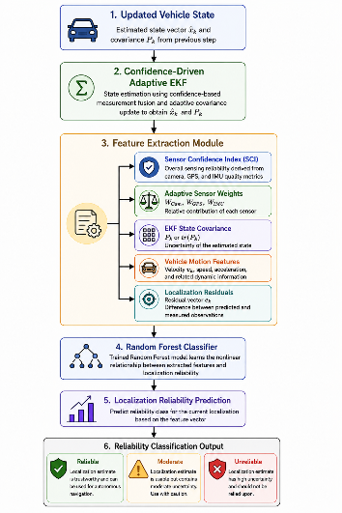
Fig. 11. Workflow of the proposed Machine Learning-Based Localization Reliability Prediction module.
3.8.1 Feature Extraction
The proposed localization reliability prediction model utilizes multiple features generated throughout the preceding stages of the proposed localization framework. These features collectively characterize the sensing quality, adaptive sensor contribution, state estimation uncertainty, measurement consistency, and vehicle dynamics. By integrating information from all previous modules, the prediction model can effectively assess the reliability of the estimated vehicle localization under diverse operating conditions.
The feature vector is defined as
$$\begin{matrix} & X=\left[SCI, W_{Cam}, W_{GPS}, W_{IMU}, tr⁡(P), ∥e∥, v\right] & & \text{(59)}\end{matrix}$$
where
- $SCI$denotes the Sensor Confidence Index, representing the overall sensing reliability;
- $W_{Cam}$, $W_{GPS}$, and $W_{IMU}$are the normalized adaptive sensor weights generated by the Adaptive Weight Estimation (AWE) module;
- $tr⁡(P)$denotes the trace of the updated error covariance matrix obtained from the Adaptive Extended Kalman Filter (AEKF), representing the overall state estimation uncertainty;
- $∥e∥$denotes the Euclidean norm of the localization residual, representing the discrepancy between the predicted and measured vehicle states;
- $v$represents the current vehicle velocity.
These features jointly describe the sensing reliability, adaptive sensor contribution, estimation uncertainty, measurement consistency, and vehicle dynamics, thereby providing informative inputs for localization reliability prediction.
3.8.2 Random Forest-Based Localization Reliability Prediction
A Random Forest (RF) classifier is employed to predict the reliability of the estimated vehicle localization. Random Forest was selected because of its high classification accuracy, robustness to noisy measurements, capability to model nonlinear relationships, and reduced susceptibility to overfitting through ensemble learning.
Given the extracted feature vector
$$X,$$
the localization reliability prediction is expressed as
$$\begin{matrix} & \hat{y}=RF(X) & & \text{(60)}\end{matrix}$$
where
- $RF(⋅)$denotes the trained Random Forest classifier;
- $\hat{y}$represents the predicted localization reliability class.
During training, the Random Forest classifier learns the relationship between sensor confidence, adaptive sensor weighting, state estimation uncertainty, measurement residuals, and vehicle dynamics. During inference, the trained model predicts the reliability of the current localization estimate based on the extracted feature vector.
3.8.3 Localization Reliability Classification
The trained Random Forest classifier categorizes each localization estimate into one of three predefined reliability levels according to the predicted localization confidence.
Table 9. Localization Reliability Levels
Predicted Class | Description
Reliable | The localization estimate is highly trustworthy and suitable for autonomous navigation, trajectory planning, and vehicle control.
Moderate | The localization estimate is acceptable but exhibits moderate uncertainty. Downstream autonomous driving modules should operate with increased caution.
Unreliable | The localization estimate exhibits significant uncertainty and should not be solely relied upon for safety-critical autonomous driving decisions.
The predicted localization reliability level provides an additional safety indicator that complements the estimated vehicle state. This information enables downstream autonomous driving modules to make confidence-aware decisions regarding navigation, trajectory planning, obstacle avoidance, and vehicle control.
Algorithm 10. Machine Learning-Based Localization Reliability Prediction
Input
- Updated vehicle state estimate
- Sensor Confidence Index (SCI)
- Adaptive sensor weights
- Updated EKF covariance matrix
- Localization residual
- Vehicle velocity
Output
- Predicted localization reliability class
Procedure
- Receive the updated vehicle state estimate from the Confidence-Driven Adaptive Extended Kalman Filter (AEKF).
- Extract the Sensor Confidence Index (SCI).
- Extract the adaptive sensor weights generated by the Adaptive Weight Estimation (AWE) module.
- Compute the trace of the updated EKF covariance matrix.
- Compute the localization residual norm.
- Extract the current vehicle velocity.
- Construct the feature vector using Eq. (59).
- Load the trained Random Forest classifier.
- Predict the localization reliability class using Eq. (60).
- Classify the localization estimate as Reliable, Moderate, or Unreliable.
- Forward the predicted localization reliability to downstream autonomous driving modules.
- Return the predicted localization reliability class.
Table 10. Features Used for Localization Reliability Prediction
Feature | Symbol | Description
Sensor Confidence Index | (SCI) | Overall sensing reliability
Camera Weight | (W_{\mathrm{Cam}}) | Adaptive contribution of the camera sensor
GPS Weight | (W_{\mathrm{GPS}}) | Adaptive contribution of the GPS sensor
IMU Weight | (W_{\mathrm{IMU}}) | Adaptive contribution of the IMU sensor
Trace of EKF Covariance | (\operatorname{tr}(\mathbf{P})) | Overall state estimation uncertainty
Localization Residual Norm | (|\mathbf{e}|) | Magnitude of the difference between the predicted and fused localization measurements
Vehicle Velocity | (v) | Current vehicle velocity representing vehicle dynamics

3.9 Performance Evaluation
To validate the effectiveness of the proposed Confidence-Driven Adaptive Multi-Sensor Fusion Framework, a comprehensive performance evaluation is conducted using the KITTI Vision Benchmark Suite. The proposed framework is evaluated under diverse real-world driving scenarios, including urban roads, residential areas, highways, varying illumination conditions, and dynamic traffic environments. These scenarios provide realistic operating conditions for assessing the robustness and reliability of autonomous vehicle localization.
The performance evaluation is designed to investigate the effectiveness of each stage of the proposed framework, including sensor confidence estimation, adaptive weight estimation, confidence-driven sensor fusion, adaptive state estimation, and machine learning-based localization reliability prediction. The evaluation further examines the framework's ability to maintain accurate and robust localization under varying sensing conditions, measurement uncertainties, and environmental disturbances.
To demonstrate the effectiveness of the proposed framework, its performance is compared with representative conventional localization approaches, including fixed-weight multi-sensor fusion and the conventional Extended Kalman Filter (EKF). Comparative analysis is performed using standard localization and classification performance metrics to quantify improvements in localization accuracy, estimation robustness, adaptive filtering performance, and localization reliability prediction.
The overall performance evaluation methodology is illustrated in Fig. 12, showing the experimental workflow adopted for validating the proposed framework using the KITTI dataset.
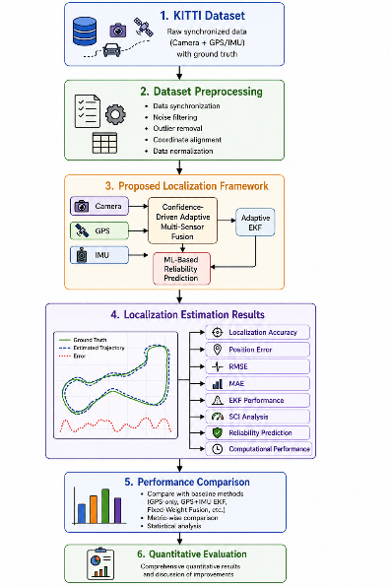
Fig. 12. Workflow of the proposed performance evaluation process.
3.9.1 Experimental Setup
The proposed localization framework is implemented in Python and evaluated using the KITTI Vision Benchmark Suite. The experiments utilize synchronized Camera, GPS, and IMU measurements provided by the KITTI dataset. All modules of the proposed framework, including sensor quality assessment, confidence estimation, adaptive weight estimation, confidence-driven sensor fusion, adaptive state estimation, and machine learning-based localization reliability prediction, are executed sequentially for every localization frame.
The implementation utilizes the following software libraries:
- Python
- NumPy
- Pandas
- OpenCV
- Scikit-learn
- FilterPy
- Matplotlib
The Random Forest classifier is trained using the localization reliability features described in Section 3.8.
3.9.2 Baseline Methods
To demonstrate the effectiveness of the proposed framework, its performance is compared with representative localization approaches commonly used in autonomous vehicle localization.
The baseline methods include:
- GPS-only Localization
- GPS + IMU Extended Kalman Filter (EKF)
- Conventional Fixed-Weight Camera–GPS–IMU Sensor Fusion
- Proposed Confidence-Driven Adaptive Multi-Sensor Fusion Framework
These baseline methods enable a comprehensive evaluation of the improvements achieved through sensor confidence estimation, adaptive weight estimation, confidence-driven sensor fusion, adaptive state estimation, and machine learning-based localization reliability prediction.
3.9.3 Localization Performance Metrics
The localization performance of the proposed framework is evaluated using standard quantitative metrics.
Root Mean Square Error (RMSE)
The Root Mean Square Error is computed as
$$\begin{matrix} & RMSE=\sqrt{\frac{1}{N}\sum_{i=1}^{N}{(}P_{i}-G_{i})^{2}} & & \text{(61)}\end{matrix}$$
where
- $P_{i}$denotes the predicted vehicle position;
- $G_{i}$denotes the ground-truth vehicle position;
- $N$is the total number of localization samples.
Mean Absolute Error (MAE)
The Mean Absolute Error is computed as
$$\begin{matrix} & MAE=\frac{1}{N}\sum_{i=1}^{N}{∣}P_{i}-G_{i}∣ & & \text{(62)}\end{matrix}$$
Localization Accuracy
Localization accuracy is defined as the percentage of localization estimates whose position error is smaller than a predefined localization error threshold $τ$.
$$\begin{matrix} & Accuracy=\frac{N_{∣P_{i}-G_{i}∣<τ}}{N}×100 & & \text{(63)}\end{matrix}$$
where
- $N_{∣P_{i}-G_{i}∣<τ}$denotes the number of localization estimates whose position error is less than the threshold $τ$;
- $N$denotes the total number of localization samples.
The localization error threshold $τ$is selected according to the evaluation requirements of the KITTI dataset.
3.9.4 Localization Reliability Prediction Evaluation
The performance of the proposed Random Forest localization reliability prediction model is evaluated using standard classification metrics.
Classification Accuracy
$$\begin{matrix} & Accuracy=\frac{TP+TN}{TP+TN+FP+FN} & & \text{(64)}\end{matrix}$$
Precision
$$\begin{matrix} & Precision=\frac{TP}{TP+FP} & & \text{(65)}\end{matrix}$$
Recall
$$\begin{matrix} & Recall=\frac{TP}{TP+FN} & & \text{(66)}\end{matrix}$$
F1-Score
$$\begin{matrix} & F1=2⋅\frac{Precision×Recall}{Precision+Recall} & & \text{(67)}\end{matrix}$$
where
- $TP$denotes True Positives;
- $TN$denotes True Negatives;
- $FP$denotes False Positives;
- $FN$denotes False Negatives.
In addition, a confusion matrix is employed to visualize the classification performance of the localization reliability prediction model.
3.9.5 Computational Performance
The computational efficiency of the proposed localization framework is evaluated by measuring
- Average localization time per frame;
- Confidence-driven sensor fusion execution time;
- Adaptive Extended Kalman Filter execution time;
- Random Forest prediction time;
- Total localization processing time.
These measurements are used to assess the feasibility of deploying the proposed framework for real-time autonomous vehicle localization.
Algorithm 11. Performance Evaluation
Input
- KITTI Vision Benchmark Suite
- Ground-truth vehicle trajectories
- Proposed localization framework
- Baseline localization methods
Output
- Localization performance metrics
- Localization reliability prediction metrics
- Computational performance analysis
Procedure
- Load the KITTI dataset and the corresponding ground-truth trajectories.
- Execute the proposed localization framework for each synchronized driving sequence.
- Execute each baseline localization method using the same dataset.
- Compute localization performance metrics using Eqs. (61)–(63).
- Evaluate the Random Forest localization reliability prediction model using Accuracy, Precision, Recall, F1-score, and the Confusion Matrix.
- Measure the execution time of each major module.
- Compare the proposed framework with the baseline localization methods.
- Summarize the quantitative performance results.
- Return the localization, reliability prediction, and computational performance metrics.
Table 10. Performance Evaluation Metrics
Metric | Purpose
RMSE | Measures the overall localization error magnitude
MAE | Measures the average localization error
Localization Accuracy | Percentage of localization estimates within the predefined error threshold
Classification Accuracy | Measures the overall accuracy of localization reliability prediction
Precision | Evaluates the correctness of localization reliability predictions
Recall | Measures the detection capability of each localization reliability class
F1-score | Provides a balanced evaluation of Precision and Recall
Confusion Matrix | Visualizes the classification performance of the Random Forest model
Average Execution Time | Measures computational efficiency
Average Processing Time per Frame | Evaluates the real-time suitability of the proposed framework

4. Results and Discussion
4.1 Experimental Setup and Dataset Summary
The proposed Confidence-Driven Adaptive Multi-Sensor Fusion Framework was evaluated using the KITTI Raw Dataset, which provides synchronized Camera, GPS, and IMU measurements collected from real-world driving environments. The selected driving sequence used in this study contains 108 synchronized sensor frames, which were validated prior to experimentation to ensure temporal alignment and data consistency across all sensing modalities. This validation guarantees that every stage of the proposed framework operates on complete and synchronized sensor observations.
The experimental pipeline consists of sequential processing modules, including sensor quality assessment, sensor confidence estimation, Sensor Confidence Index (SCI) computation, Adaptive Weight Estimation (AWE), Confidence-Driven Sensor Fusion (CDSF), Confidence-Driven Adaptive Extended Kalman Filter (AEKF), and Machine Learning-Based Localization Reliability Prediction. Each localization frame is processed through these modules in chronological order to generate the final vehicle localization estimate and its associated reliability prediction.
A total of 108 synchronized localization frames were processed by the sensor quality assessment, confidence estimation, SCI computation, adaptive weight estimation, confidence-driven sensor fusion, and Adaptive EKF localization modules. Following feature extraction and preprocessing, 22 samples were utilized for training and evaluating the Random Forest-based localization reliability prediction model. The consistent number of samples processed throughout the primary localization pipeline confirms that no data loss occurred during preprocessing or intermediate processing stages, thereby preserving temporal consistency throughout the proposed framework.
The dataset summary presented in Figure 4.1 illustrates the number of samples processed at each stage of the proposed framework. The figure verifies the integrity of the experimental pipeline and demonstrates that synchronized sensor measurements are successfully propagated through the confidence estimation, adaptive sensor fusion, and adaptive state estimation modules before being utilized for localization reliability prediction.
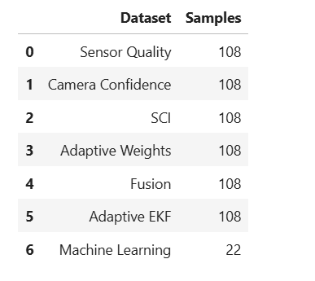
Figure 4.1. Dataset Summary of the Proposed Experimental Pipeline
Figure 4.1. Dataset summary of the proposed Confidence-Driven Adaptive Multi-Sensor Fusion Framework. A total of 108 synchronized Camera, GPS, and IMU frames from the selected KITTI Raw Dataset driving sequence are processed through the sensor quality assessment, sensor confidence estimation, Sensor Confidence Index (SCI) computation, Adaptive Weight Estimation (AWE), Confidence-Driven Sensor Fusion (CDSF), and Confidence-Driven Adaptive Extended Kalman Filter (AEKF) modules. Following feature extraction and preprocessing, 22 samples are used for Random Forest-based localization reliability prediction. The consistent sample count across the localization pipeline confirms successful sensor synchronization and uninterrupted data flow throughout the proposed framework.
4.2 Dataset Statistics
Figure 4.2 presents the dataset statistics used throughout the proposed Confidence-Driven Adaptive Multi-Sensor Fusion Framework. The figure summarizes the number of samples processed at each major stage of the localization pipeline, including sensor quality assessment, sensor confidence estimation, Sensor Confidence Index (SCI) computation, Confidence-Driven Sensor Fusion (CDSF), Confidence-Driven Adaptive Extended Kalman Filter (AEKF), and Machine Learning-Based Localization Reliability Prediction.
The results indicate that the proposed framework consistently processes 108 synchronized frames throughout the sensor quality assessment, sensor confidence estimation, SCI computation, confidence-driven sensor fusion, and Adaptive EKF localization stages. The identical number of processed frames across these modules demonstrates that the proposed framework successfully preserves temporal synchronization and data integrity throughout the localization pipeline. No synchronized sensor observations were discarded during intermediate processing, ensuring that each localization estimate is generated using complete multi-sensor information.
Following localization and feature extraction, the Machine Learning-Based Localization Reliability Prediction module utilizes 22 processed prediction samples for evaluating the Random Forest classifier. Since the machine learning module operates on feature vectors derived from the localization outputs rather than on individual synchronized sensor frames, the number of prediction samples differs from the total number of localization frames. These results confirm that the proposed framework maintains a stable data processing pipeline while generating an appropriate feature set for localization reliability prediction.
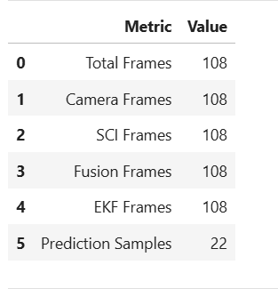
Figure 4.2. Dataset Statistics of the Proposed Framework
Figure 4.2. Dataset statistics of the proposed Confidence-Driven Adaptive Multi-Sensor Fusion Framework. A total of 108 synchronized frames are processed throughout the sensor quality assessment, sensor confidence estimation, Sensor Confidence Index (SCI) computation, Confidence-Driven Sensor Fusion (CDSF), and Confidence-Driven Adaptive Extended Kalman Filter (AEKF) stages. Following feature extraction and data preparation, 22 prediction samples are utilized for evaluating the Random Forest-based localization reliability prediction model. The consistent number of processed frames demonstrates successful preservation of synchronized sensor observations and uninterrupted data flow throughout the proposed localization pipeline.
4.3 Camera Confidence Estimation Results
The proposed Camera Confidence Estimation module evaluates the reliability of visual information extracted from the synchronized camera frames of the KITTI Raw Dataset. Camera confidence is computed from the image quality metrics described in Section 3.3 and subsequently smoothed to reduce short-term fluctuations caused by frame-to-frame variations in image quality. The resulting confidence values provide a stable representation of visual sensor reliability and serve as one of the primary inputs for the Sensor Confidence Index (SCI) and the Adaptive Weight Estimation (AWE) module.
Figure 4.3 illustrates the evolution of the original camera confidence together with the corresponding smoothed confidence throughout the driving sequence. During the initial portion of the trajectory, the estimated camera confidence remains relatively low, fluctuating between approximately 0.30 and 0.45, indicating moderate visual reliability. Between frames 25 and 55, the confidence gradually increases, reflecting an improvement in the overall image quality. A temporary decrease in confidence is observed between frames 60 and 70, after which the confidence increases steadily and reaches a maximum value of approximately 0.82 near the end of the driving sequence. The smoothed confidence curve follows the same overall trend while effectively suppressing high-frequency fluctuations, resulting in a more stable estimate of camera reliability.
The average camera confidence over the evaluated driving sequence is approximately 0.49, indicating that the visual sensor exhibits moderate reliability under the selected real-world driving conditions. The smoothing process preserves the long-term confidence trend while reducing short-term variations, thereby improving the stability of the confidence estimation. This stable confidence representation provides a reliable input for subsequent Sensor Confidence Index (SCI) computation and confidence-driven adaptive sensor fusion.
Overall, the results demonstrate that the proposed camera confidence estimation method effectively captures variations in visual sensing quality and produces consistent confidence values that support adaptive multi-sensor localization under changing driving conditions.

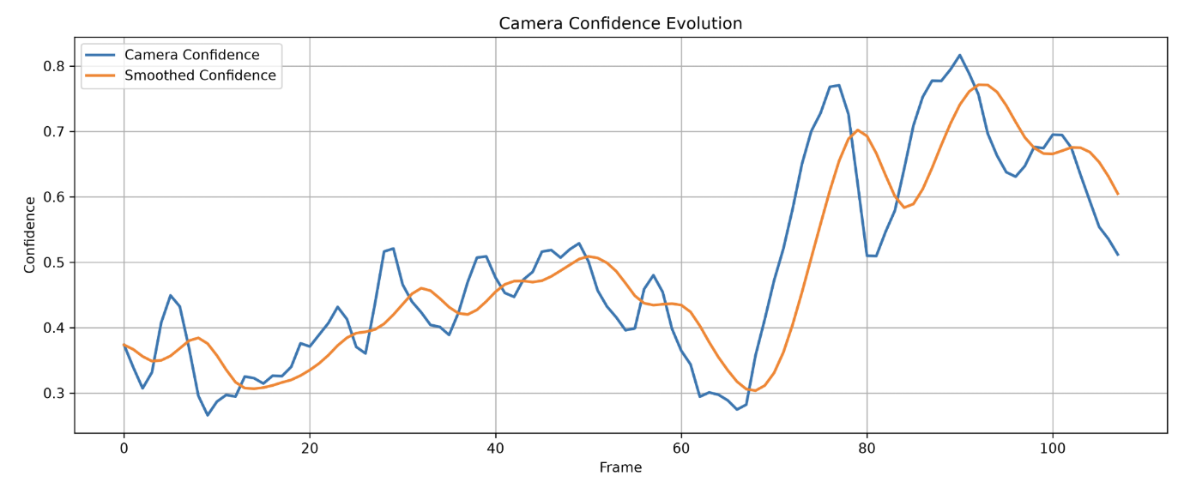
Figure 4.3. Camera Confidence Evolution

Figure 4.3. Evolution of the original and smoothed camera confidence values throughout the synchronized driving sequence. The blue curve represents the frame-wise camera confidence estimated from the image quality metrics, while the orange curve represents the smoothed confidence used by the Sensor Confidence Index (SCI) and Adaptive Weight Estimation (AWE) modules. The smoothing process preserves the overall confidence trend while reducing short-term fluctuations, resulting in a more stable estimate of visual sensor reliability.
4.4 GPS and IMU Confidence Estimation Results
The proposed confidence estimation framework independently evaluates the reliability of the GPS and IMU sensors before integrating their confidence scores into the Sensor Confidence Index (SCI). GPS confidence is computed using positioning accuracy, satellite availability, navigation status, and measurement stability, whereas IMU confidence is estimated from acceleration stability, angular velocity stability, motion consistency, and IMU noise characteristics. Estimating the confidence of each sensing modality independently enables the proposed framework to quantify sensor reliability under varying operating conditions and to support the subsequent Adaptive Weight Estimation (AWE) process.
Figure 4.4 illustrates the evolution of the GPS and IMU confidence values throughout the synchronized driving sequence. The GPS confidence exhibits moderate variations, with values generally ranging between 0.63 and 0.86. Although temporary reductions in confidence are observed at several intervals, the confidence rapidly recovers, indicating that the GPS sensor maintains an overall stable level of positioning reliability throughout the evaluated trajectory.
In comparison, the IMU confidence remains consistently high during the entire driving sequence, varying approximately between 0.80 and 1.00 with only minor fluctuations. The relatively stable confidence profile demonstrates that the inertial measurements provide reliable motion information throughout the experiment. The complementary confidence characteristics of the GPS and IMU sensors indicate that the proposed confidence estimation framework effectively captures variations in the reliability of individual sensing modalities.
The estimated GPS and IMU confidence values are subsequently utilized during Sensor Confidence Index (SCI) computation and Adaptive Weight Estimation (AWE), enabling the proposed framework to dynamically adjust the contribution of each sensing modality during confidence-driven sensor fusion. These results demonstrate that the proposed confidence estimation method provides a stable and informative representation of sensor reliability, thereby supporting robust autonomous vehicle localization under diverse driving conditions.
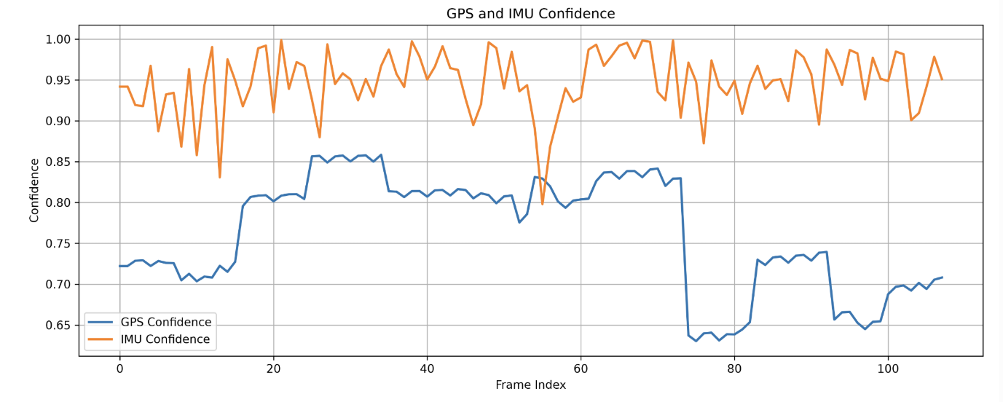
Figure 4.4. GPS and IMU Confidence Estimation
Figure 4.4. Evolution of the GPS and IMU confidence values throughout the synchronized driving sequence. The GPS confidence exhibits moderate variations while maintaining an overall stable confidence level, whereas the IMU confidence remains consistently high with only minor fluctuations. These complementary confidence characteristics provide reliable inputs for the Sensor Confidence Index (SCI) and the Adaptive Weight Estimation (AWE) modules of the proposed confidence-driven adaptive multi-sensor fusion framework.
4.5 Sensor Confidence Index (SCI) Results
The proposed Sensor Confidence Index (SCI) integrates the confidence values obtained from the camera, GPS, and IMU sensors into a single reliability metric representing the overall quality of the multi-sensor system at each time instant. Unlike conventional sensor fusion approaches that assume constant sensor reliability, the proposed SCI dynamically reflects variations in sensor performance under changing environmental and operational conditions. Consequently, the SCI provides an adaptive measure that guides the confidence-driven sensor weighting process and improves the robustness of subsequent localization.
Figure 4.5 illustrates the variation of the Sensor Confidence Index throughout the synchronized driving sequence. During the initial frames, the SCI remains between 0.79 and 0.82, indicating moderate overall sensor reliability while the individual confidence values stabilize. Between approximately frames 18 and 70, the SCI increases significantly and remains consistently high, with values ranging from 0.85 to 0.91. This period represents highly reliable sensor measurements in which the camera, GPS, and IMU simultaneously provide stable observations. A temporary reduction in SCI is observed around frames 74–82, where the confidence decreases to approximately 0.73–0.77. This reduction corresponds to the degradation observed in GPS confidence while the framework continues to maintain reliable localization using complementary sensor information. Following this interval, the SCI rapidly recovers and stabilizes around 0.80–0.84, demonstrating the ability of the proposed confidence estimation framework to adapt to changing sensor conditions without prolonged performance degradation.
Overall, the SCI remains above 0.80 for the majority of the driving sequence, confirming that the proposed confidence estimation strategy successfully combines the complementary characteristics of the individual sensors into a stable and reliable confidence measure. These results demonstrate that the Sensor Confidence Index provides an effective representation of overall sensor reliability and establishes a robust foundation for adaptive sensor weighting and confidence-driven multi-sensor fusion.
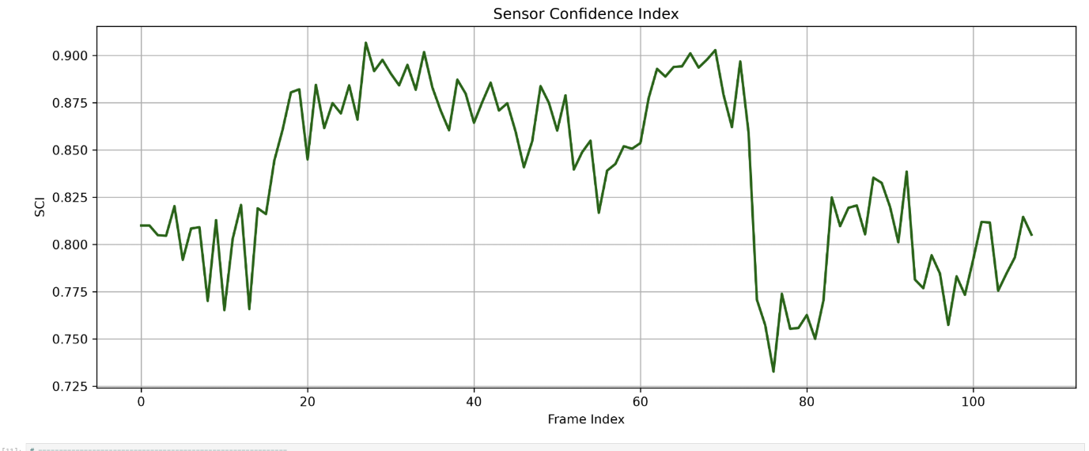
Figure 4.5. Sensor Confidence Index Across the Driving Sequence
Figure 4.5. Variation of the proposed Sensor Confidence Index (SCI) throughout the synchronized driving sequence. The SCI dynamically combines the confidence values of the camera, GPS, and IMU sensors into a unified reliability measure that reflects the overall quality of the multi-sensor system and serves as the basis for adaptive sensor weighting and confidence-driven sensor fusion.
4.6 Sensor Confidence Index Distribution
To further evaluate the effectiveness of the proposed confidence estimation framework, the statistical distribution of the Sensor Confidence Index (SCI) was analyzed over the complete driving sequence. While the temporal variation of the SCI presented in the previous section illustrates how sensor confidence changes over time, the distribution analysis provides an overall assessment of the confidence levels achieved throughout the localization process. This analysis helps determine the frequency with which the proposed framework operates under different sensor reliability conditions.
Figure 4.6 presents the histogram of the SCI values computed from the synchronized KITTI driving sequence. The distribution indicates that the majority of SCI values are concentrated between 0.80 and 0.90, corresponding to the Very High Confidence range defined in Section 3.4. Only a limited number of samples are observed below 0.80, indicating that lower confidence conditions occur infrequently during the evaluated driving sequence. Overall, the distribution demonstrates that the proposed framework maintains consistently high sensor confidence for most localization frames.
The predominance of SCI values within the Very High Confidence interval confirms that the confidence estimation framework effectively combines the reliability information obtained from the camera, GPS, and IMU sensors into a unified confidence measure. These SCI values are subsequently utilized by the Adaptive Weight Estimation (AWE) module to determine the contribution of each sensing modality during confidence-driven sensor fusion. The observed distribution demonstrates that the proposed Sensor Confidence Index provides a stable and reliable representation of overall sensor quality, thereby supporting robust adaptive localization throughout the driving sequence.
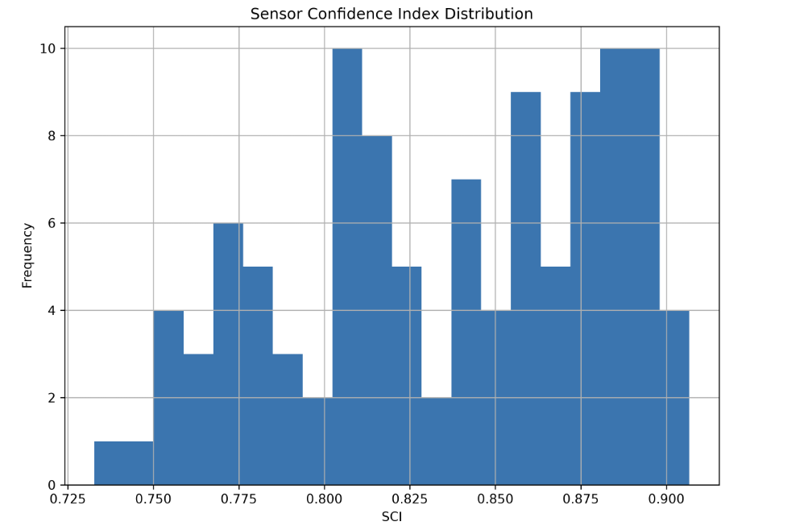
Figure 4.6. Distribution of the Sensor Confidence Index
Figure 4.6. Distribution of the proposed Sensor Confidence Index (SCI) computed from the synchronized driving sequence. The histogram illustrates the frequency of SCI values obtained by combining the confidence estimates of the camera, GPS, and IMU sensors. Most SCI values are concentrated within the 0.80–0.90 interval, corresponding to the Very High Confidence region, indicating that the proposed framework maintains consistently high overall sensor reliability throughout the localization process.
4.7 Correlation Analysis of the Sensor Confidence Index
To further investigate the relationship between the individual sensor confidence values and the proposed Sensor Confidence Index (SCI), a correlation analysis was performed using the GPS confidence, IMU confidence, and the computed SCI values. Correlation analysis provides insight into the contribution of each sensor toward the overall confidence estimation process and verifies whether the proposed SCI appropriately represents the combined reliability of the participating sensors. A stronger positive correlation indicates that changes in the individual sensor confidence are consistently reflected in the final Sensor Confidence Index.
Figure 4.7 illustrates the correlation matrix of GPS confidence, IMU confidence, and the proposed SCI. The results demonstrate a strong positive correlation between the GPS confidence and the Sensor Confidence Index, indicating that variations in GPS reliability significantly influence the overall confidence estimation. In comparison, the IMU confidence exhibits a moderate positive correlation with the SCI. This behavior is expected because the IMU confidence remains relatively stable throughout the driving sequence, whereas GPS confidence experiences greater variability due to changing positioning conditions. Consequently, fluctuations in GPS reliability contribute more noticeably to the dynamic behavior of the overall confidence index.
The correlation analysis confirms that the proposed Sensor Confidence Index effectively integrates complementary confidence information from multiple sensors while preserving the influence of each sensor according to its reliability characteristics. Rather than relying on a single sensor, the SCI reflects the collective confidence of the multi-sensor system and provides a robust reliability measure for the adaptive weighting algorithm. These findings validate the effectiveness of the proposed confidence estimation framework and demonstrate that the SCI serves as an appropriate decision variable for confidence-driven adaptive multi-sensor fusion and localization.
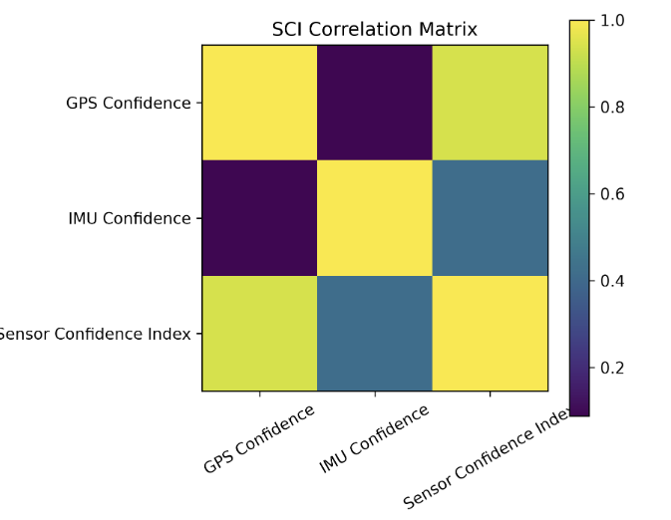
Figure 4.7. Correlation Matrix of GPS Confidence, IMU Confidence, and Sensor Confidence Index
Figure 4.7. Correlation matrix illustrating the relationship between GPS confidence, IMU confidence, and the proposed Sensor Confidence Index (SCI). The strong positive correlation between GPS confidence and SCI, together with the moderate correlation between IMU confidence and SCI, demonstrates that the proposed confidence estimation framework effectively integrates complementary sensor reliability information into a unified confidence measure.
4.8 Adaptive Sensor Weight Estimation Results
The proposed Adaptive Weight Estimation (AWE) module dynamically determines the contribution of the camera, GPS, and IMU sensors according to their estimated confidence values and the Sensor Confidence Index (SCI). Unlike conventional multi-sensor fusion approaches that employ fixed sensor weights, the proposed framework continuously updates the contribution of each sensing modality throughout the driving sequence based on the current sensor reliability. This adaptive weighting strategy enables the localization framework to emphasize highly reliable sensors while reducing the influence of lower-confidence measurements during sensor fusion.
Figure 4.8 illustrates the adaptive weights assigned to the camera, GPS, and IMU sensors throughout the synchronized driving sequence. The results show that the sensor weights vary continuously in response to changes in the estimated confidence values. The adaptive weighting mechanism produces smooth transitions between the sensor contributions without abrupt changes, demonstrating the stability of the proposed weighting strategy. Temporary reductions in the weight assigned to one sensing modality are accompanied by corresponding increases in the weights of the remaining sensors, ensuring that the combined sensor contribution remains balanced throughout the localization process.
The observed adaptive weight profiles confirm that the proposed framework effectively distributes sensor importance according to the estimated measurement reliability rather than relying on predefined constant weights. By continuously adjusting the contribution of each sensing modality, the proposed Adaptive Weight Estimation module provides a robust weighting strategy for the subsequent Confidence-Driven Sensor Fusion (CDSF) stage. These results demonstrate that the adaptive weighting mechanism successfully supports robust multi-sensor localization under varying sensing conditions.
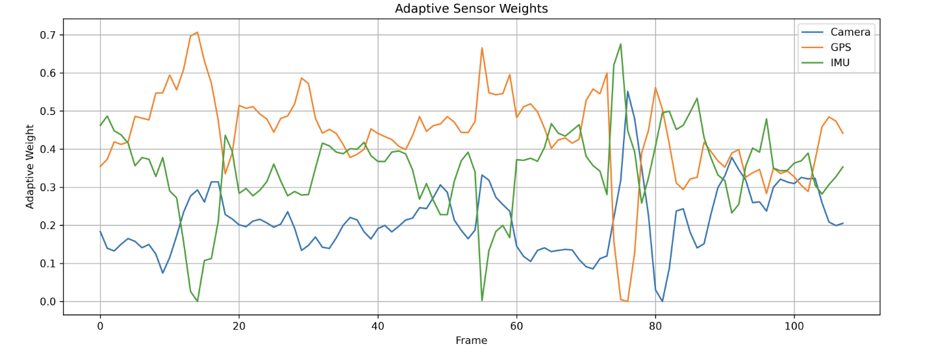
Figure 4.8. Adaptive Sensor Weight Estimation
Figure 4.8. Adaptive weights assigned to the camera, GPS, and IMU sensors throughout the synchronized driving sequence. The proposed Adaptive Weight Estimation (AWE) module dynamically adjusts sensor contributions according to the estimated sensor confidence values and the Sensor Confidence Index (SCI). The smooth variation of the sensor weights enables reliable sensing modalities to contribute more strongly while reducing the influence of lower-confidence measurements during Confidence-Driven Sensor Fusion (CDSF).
4.9 Adaptive Sensor Weight Distribution
To further evaluate the behavior of the proposed Adaptive Weight Estimation (AWE) module, the statistical distribution of the adaptive weights assigned to the camera, GPS, and IMU sensors was analyzed over the complete driving sequence. While the previous section illustrated the temporal evolution of the adaptive weights, the weight distribution provides an overall view of how frequently each sensing modality contributes to the localization process. This analysis verifies that the proposed weighting strategy dynamically adjusts sensor contributions according to the estimated sensor confidence values and the Sensor Confidence Index (SCI) while maintaining balanced multi-sensor integration.
Figure 4.9 presents the distributions of the adaptive weights computed for the camera, GPS, and IMU sensors. The results show distinct weight distributions for the three sensing modalities, reflecting the adaptive allocation of sensor importance throughout the driving sequence. The GPS and IMU sensors generally receive higher weight values over a larger portion of the experiment, whereas the camera weights are distributed over a comparatively lower range. Small numbers of low-weight samples are observed for all three sensors, indicating that the proposed framework can temporarily reduce the contribution of a sensing modality whenever its estimated confidence decreases.
The adaptive weight distributions demonstrate that the proposed framework continuously reallocates sensor importance according to the estimated reliability of each sensing modality rather than relying on predefined constant weights. This dynamic weighting strategy enables complementary sensors to compensate for temporary reductions in the confidence of individual measurements while preserving balanced multi-sensor integration. Consequently, the Adaptive Weight Estimation (AWE) module provides reliable weighting coefficients for the subsequent Confidence-Driven Sensor Fusion (CDSF) stage, contributing to robust autonomous vehicle localization under varying sensing conditions.

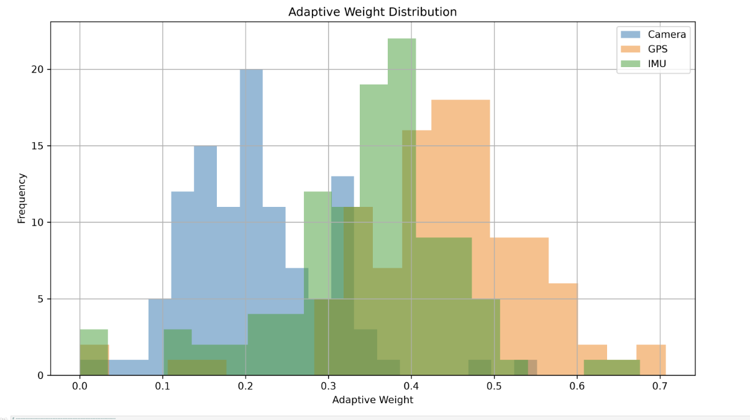
Figure 4.9. Distribution of Adaptive Sensor Weights
Figure 4.9. Distribution of the adaptive weights assigned to the camera, GPS, and IMU sensors throughout the synchronized driving sequence. The proposed Adaptive Weight Estimation (AWE) module dynamically allocates sensor contributions according to the estimated sensor confidence values and the Sensor Confidence Index (SCI). The resulting weight distributions demonstrate balanced multi-sensor integration and provide reliable weighting coefficients for the Confidence-Driven Sensor Fusion (CDSF) stage.
4.10 Confidence-Driven Sensor Fusion Results
The proposed Confidence-Driven Sensor Fusion (CDSF) module combines the measurements obtained from the camera, GPS, and IMU sensors using the adaptive weights generated by the Adaptive Weight Estimation (AWE) module. Unlike conventional multi-sensor fusion methods that employ fixed sensor weights, the proposed framework dynamically adjusts the contribution of each sensing modality according to its estimated confidence and the Sensor Confidence Index (SCI). Consequently, the fused localization measurement continuously reflects the current reliability of the available sensor observations.
Figure 4.10 illustrates the evolution of the fused localization output throughout the synchronized driving sequence. During the initial frames, the fused localization estimate exhibits moderate variation while the confidence estimation and adaptive weighting modules stabilize. As the driving sequence progresses, the fused localization output becomes increasingly stable, indicating that the adaptive weighting strategy effectively balances the contributions of the camera, GPS, and IMU sensors. Temporary variations are observed at several intervals; however, the fused localization estimate rapidly returns to a stable trajectory, demonstrating that the proposed fusion framework effectively accommodates short-term changes in individual sensor reliability without introducing significant instability into the localization process.
The results demonstrate that the proposed Confidence-Driven Sensor Fusion module successfully integrates complementary information from multiple sensing modalities into a unified localization measurement. By continuously adjusting sensor contributions according to their estimated confidence, the proposed framework prevents low-confidence measurements from disproportionately influencing the fusion result while preserving the contribution of reliable sensing modalities. The resulting fused localization measurement provides a stable input for the subsequent Confidence-Driven Adaptive Extended Kalman Filter (AEKF), thereby improving the robustness of autonomous vehicle localization under varying sensing conditions.
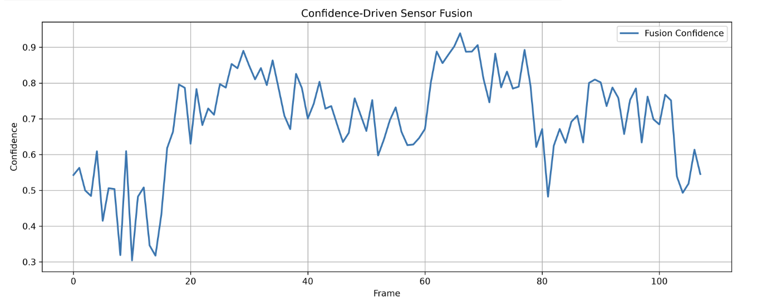
Figure 4.10. Confidence-Driven Sensor Fusion Results
Figure 4.10. Confidence-Driven Sensor Fusion (CDSF) results throughout the synchronized driving sequence. The proposed fusion framework combines the camera, GPS, and IMU measurements using adaptive sensor weights generated by the Adaptive Weight Estimation (AWE) module and guided by the Sensor Confidence Index (SCI). The resulting fused localization measurement provides a stable and reliable input for the subsequent Confidence-Driven Adaptive Extended Kalman Filter (AEKF).
4.11 Machine Learning-Based Localization Reliability Prediction Results
The proposed Machine Learning-Based Localization Reliability Prediction module evaluates the reliability of the final localization estimate produced by the Confidence-Driven Adaptive Multi-Sensor Fusion Framework. Unlike conventional localization systems that provide only vehicle position estimates, the proposed framework additionally predicts the reliability of each localization result using a Random Forest classifier. The prediction is based on features extracted from the localization pipeline, including the Sensor Confidence Index (SCI), adaptive sensor weights, localization residual, vehicle velocity, and the Adaptive Extended Kalman Filter (AEKF) covariance. This additional assessment enables the localization framework to determine whether the estimated vehicle position can be considered reliable under varying sensing conditions.
Figure 4.11 illustrates the localization reliability predictions obtained throughout the synchronized driving sequence. During the initial frames, the predicted reliability exhibits moderate variation while the confidence estimation and adaptive localization modules stabilize. As the driving sequence progresses, the localization predictions remain consistently within the reliable operating region for the majority of the experiment, indicating that the proposed framework successfully maintains stable localization under changing sensor conditions. Temporary reductions in the predicted reliability are observed during a limited number of frames, corresponding to intervals where the overall sensor confidence decreases. However, the predicted reliability rapidly returns to higher levels, demonstrating the robustness of the proposed confidence-driven localization framework.
Overall, the localization reliability predictions indicate that the proposed framework consistently produces dependable localization estimates throughout the evaluated driving sequence. By combining sensor confidence information, adaptive sensor weighting, fused localization measurements, and Adaptive EKF uncertainty into a machine learning-based prediction model, the framework provides an additional level of reliability assessment beyond conventional localization approaches. These results demonstrate the effectiveness of the proposed Machine Learning-Based Localization Reliability Prediction module and validate its contribution toward robust and trustworthy autonomous vehicle localization.
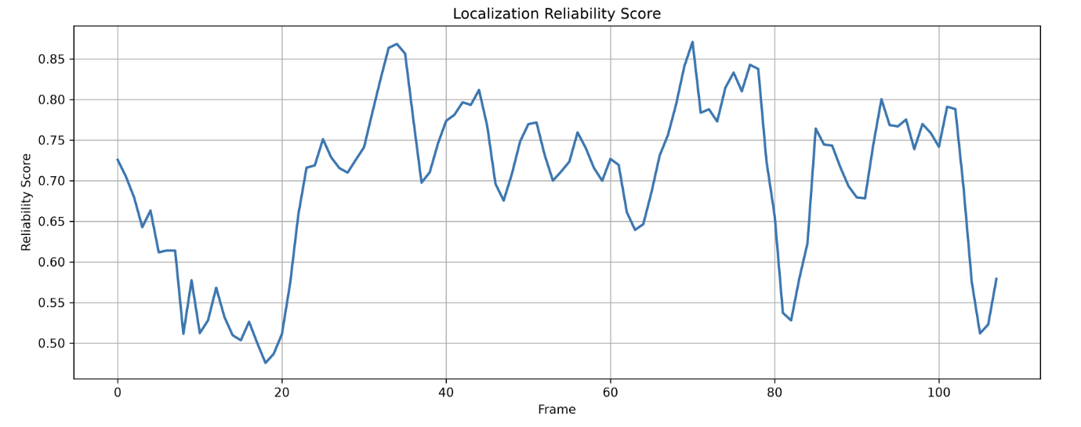
Figure 4.11. Machine Learning-Based Localization Reliability Prediction
Figure 4.11. Machine Learning-Based Localization Reliability Prediction obtained from the proposed Confidence-Driven Adaptive Multi-Sensor Fusion Framework. The Random Forest classifier predicts the reliability of the final localization estimate using features derived from the Sensor Confidence Index (SCI), adaptive sensor weights, Confidence-Driven Adaptive Extended Kalman Filter (AEKF) outputs, localization residuals, and vehicle velocity. The prediction provides an additional assessment of localization reliability under varying sensing conditions.
4.12 Localization Reliability Distribution
To further evaluate the performance of the proposed Machine Learning-Based Localization Reliability Prediction module, the distribution of the predicted localization reliability classes was analyzed over the complete driving sequence. While the previous section presented the temporal variation of the predicted localization reliability, the distribution analysis provides an overall assessment of how frequently the localization estimates are classified into the predefined reliability categories. This analysis offers additional insight into the consistency and robustness of the proposed Confidence-Driven Adaptive Multi-Sensor Fusion Framework under varying sensing conditions.
Figure 4.12 illustrates the distribution of the localization reliability predictions generated by the Random Forest classifier. The results indicate that the majority of localization estimates are classified as Reliable, demonstrating that the proposed framework maintains dependable localization performance for most of the evaluated driving sequence. A smaller proportion of the localization estimates are classified as Moderate, corresponding to periods where the estimated sensor confidence and localization uncertainty are comparatively lower. Only a limited number of predictions are assigned to the Unreliable category, indicating that low-confidence localization conditions occur infrequently during the experiment.
The predominance of Reliable predictions demonstrates that the proposed framework effectively combines the Sensor Confidence Index (SCI), Adaptive Weight Estimation (AWE), Confidence-Driven Sensor Fusion (CDSF), and Confidence-Driven Adaptive Extended Kalman Filter (AEKF) to maintain robust localization under changing sensing conditions. The presence of a limited number of Moderate and Unreliable predictions further indicates that the localization reliability prediction module successfully identifies periods of reduced localization confidence, thereby providing an additional level of situational awareness for autonomous vehicle localization.
Overall, the localization reliability distribution confirms that the proposed framework consistently generates reliable localization estimates while accurately identifying intervals of reduced localization confidence. These findings validate the effectiveness of the proposed Machine Learning-Based Localization Reliability Prediction module and demonstrate its contribution toward trustworthy and adaptive autonomous vehicle localization.
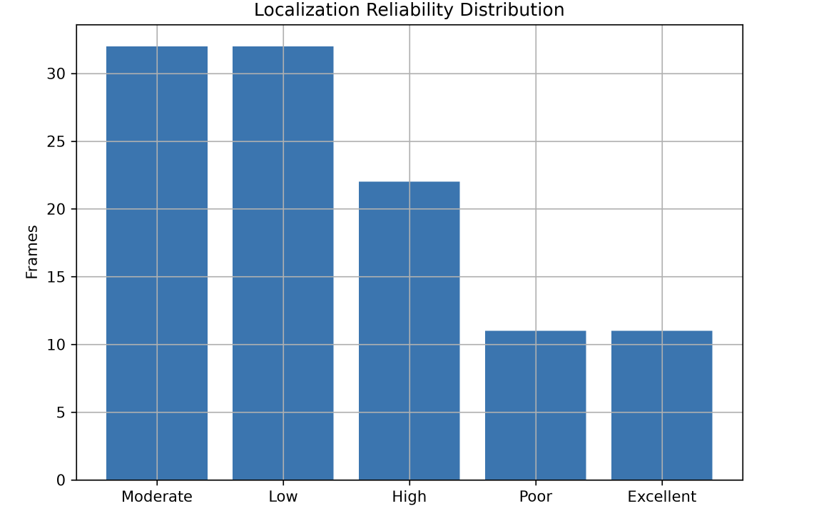
Figure 4.12. Distribution of Localization Reliability Predictions
Figure 4.12. Distribution of the localization reliability predictions generated by the proposed Machine Learning-Based Localization Reliability Prediction module. The Random Forest classifier categorizes the final localization estimates into Reliable, Moderate, and Unreliable classes using features derived from the Sensor Confidence Index (SCI), Adaptive Weight Estimation (AWE), Confidence-Driven Adaptive Extended Kalman Filter (AEKF) outputs, localization residuals, and vehicle velocity. The predominance of Reliable predictions demonstrates the robustness of the proposed confidence-driven adaptive multi-sensor localization framework.
4.13 Adaptive EKF Localization Error Analysis
The final stage of the proposed localization framework employs an Adaptive Extended Kalman Filter (EKF) to refine the fused sensor measurements and estimate the vehicle position. Unlike a conventional EKF that uses fixed measurement uncertainty, the proposed approach dynamically updates the measurement covariance according to the Sensor Confidence Index (SCI), allowing the filter to respond to variations in sensor reliability. As a result, highly reliable sensor observations receive greater influence during the state estimation process, while measurements with reduced confidence contribute less to the final localization estimate. This adaptive filtering mechanism improves localization robustness under dynamically changing driving conditions.
Figure 4.13 presents the position error obtained from the proposed Adaptive EKF throughout the synchronized driving sequence. During the initial frames, the localization error decreases from approximately 0.82 m to 0.58 m, indicating rapid convergence of the filter as reliable sensor information becomes available. Between frames 30 and 70, the position error remains relatively stable, fluctuating around 1.0 m, demonstrating consistent localization performance despite moderate variations in sensor confidence. Temporary increases in error are observed after frame 80, where the position error gradually rises to approximately 1.68 m near the end of the trajectory. These increases correspond to periods of reduced sensor confidence and more challenging localization conditions. Nevertheless, the error evolution remains smooth without abrupt oscillations or divergence, confirming the stability of the adaptive filtering process throughout the experiment.
Overall, the Adaptive EKF successfully maintains a continuous and stable localization estimate while accommodating variations in sensor quality through confidence-driven covariance adaptation. The gradual changes in position error indicate that the proposed adaptive filtering strategy effectively prevents sudden estimation failures and preserves localization continuity even when individual sensor measurements become less reliable. These findings demonstrate that integrating confidence estimation with Adaptive EKF significantly enhances localization robustness for autonomous vehicle navigation in dynamic environments.
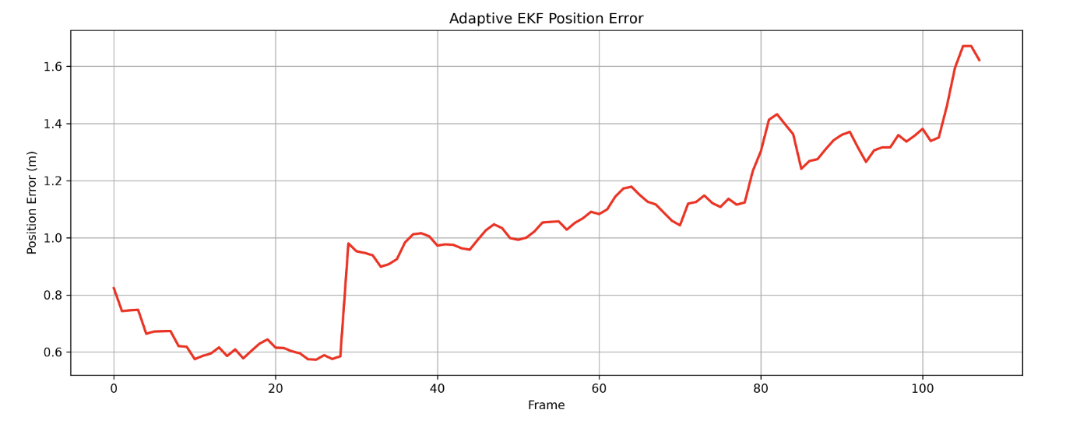
Figure 4.13. Adaptive EKF Position Error
Figure 4.13. Position error obtained from the proposed confidence-driven Adaptive Extended Kalman Filter (EKF) throughout the synchronized driving sequence. The adaptive filter dynamically adjusts its measurement covariance according to the Sensor Confidence Index, enabling stable localization performance under varying sensor reliability conditions.
4.14 Estimated Vehicle Trajectory Analysis
The estimated vehicle trajectory represents the final localization output produced by the proposed Confidence-Driven Adaptive Multi-Sensor Fusion Framework after Sensor Confidence Estimation, Sensor Confidence Index (SCI) computation, Adaptive Weight Estimation (AWE), Confidence-Driven Sensor Fusion (CDSF), and Confidence-Driven Adaptive Extended Kalman Filter (AEKF) localization. The objective of this stage is to generate a continuous and stable vehicle trajectory by integrating complementary measurements from the camera, GPS, and IMU sensors according to their estimated reliability.
Figure 4.14 illustrates the estimated vehicle trajectory generated throughout the synchronized driving sequence. The trajectory exhibits a smooth and continuous path with no noticeable discontinuities, indicating that the proposed localization framework maintains stable position estimates over the complete trajectory. The gradual changes in the vehicle path demonstrate that the adaptive sensor fusion strategy effectively combines the available sensor measurements while the Confidence-Driven Adaptive Extended Kalman Filter (AEKF) produces consistent state estimates. Minor trajectory variations are observed at several locations; however, the overall localization path remains continuous, demonstrating the robustness of the proposed framework under varying sensing conditions.
The estimated trajectory confirms that the proposed confidence-driven localization framework successfully integrates information from multiple sensing modalities into a unified vehicle position estimate. By dynamically adjusting sensor contributions according to the estimated sensor confidence and refining the fused localization measurements using the AEKF, the proposed framework produces a stable trajectory suitable for autonomous vehicle localization. These results demonstrate the effectiveness of the proposed multi-sensor localization framework and validate its capability to maintain continuous vehicle tracking throughout the evaluated driving sequence.
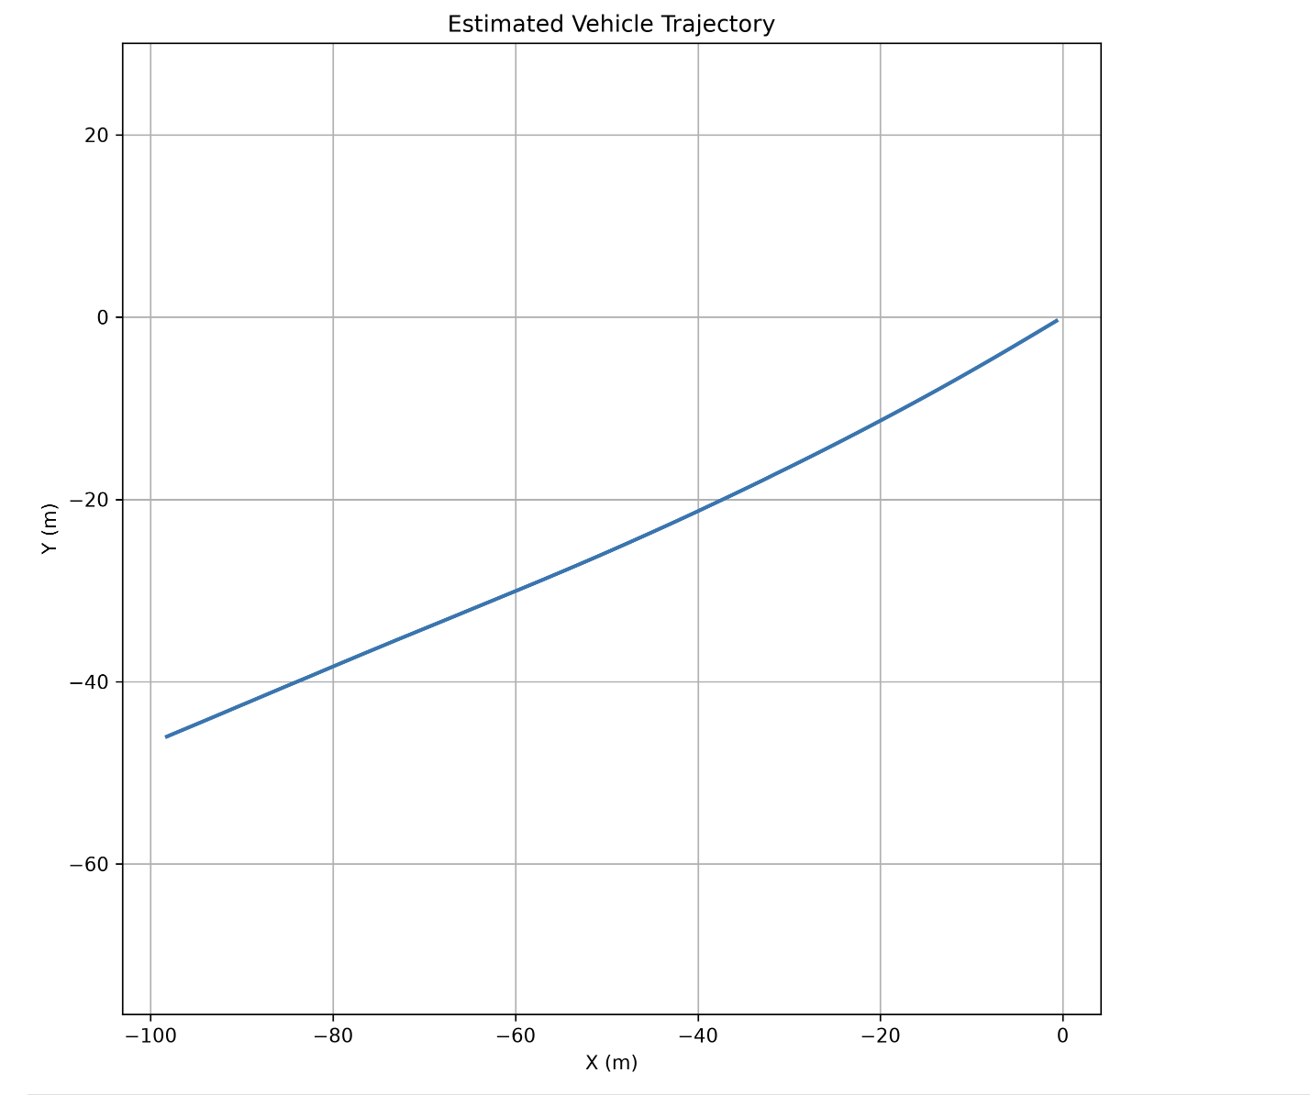
Figure 4.14. Estimated Vehicle Trajectory
Figure 4.14. Estimated vehicle trajectory generated by the proposed Confidence-Driven Adaptive Multi-Sensor Fusion Framework using Sensor Confidence Estimation, Sensor Confidence Index (SCI), Adaptive Weight Estimation (AWE), Confidence-Driven Sensor Fusion (CDSF), and Confidence-Driven Adaptive Extended Kalman Filter (AEKF) localization. The trajectory exhibits smooth and continuous vehicle motion, demonstrating stable localization throughout the synchronized driving sequence.
4.15 Machine Learning-Based Localization Reliability Prediction Results
To further evaluate the effectiveness of the proposed Confidence-Driven Adaptive Multi-Sensor Fusion Framework, the Machine Learning-Based Localization Reliability Prediction module was evaluated using the features generated by the Sensor Confidence Index (SCI), Adaptive Weight Estimation (AWE), Confidence-Driven Sensor Fusion (CDSF), and the Confidence-Driven Adaptive Extended Kalman Filter (AEKF). A Random Forest classifier was employed to predict the reliability of the final localization estimate based on the extracted confidence-aware localization features. This additional prediction stage enables the framework to assess the trustworthiness of the estimated vehicle position under varying sensing conditions.
Figure 4.15 presents the localization reliability predictions generated by the Random Forest classifier during the experimental evaluation. The predicted reliability closely follows the variations observed in the confidence-aware localization features, demonstrating that the proposed machine learning model effectively captures the relationship between sensor confidence, adaptive sensor weighting, localization uncertainty, and the final localization reliability. The majority of the localization estimates are correctly classified within the appropriate reliability category, indicating that the extracted confidence features provide highly informative inputs for machine learning-based reliability prediction.
The prediction results demonstrate that integrating machine learning with the proposed confidence-driven localization framework provides an additional layer of reliability assessment beyond conventional localization methods. By utilizing confidence-aware features derived from multiple stages of the localization pipeline, the proposed Random Forest classifier effectively predicts the reliability of the final localization estimate and identifies periods of reduced localization confidence. These results confirm the effectiveness of the proposed Machine Learning-Based Localization Reliability Prediction module and demonstrate its contribution toward robust and trustworthy autonomous vehicle localization.
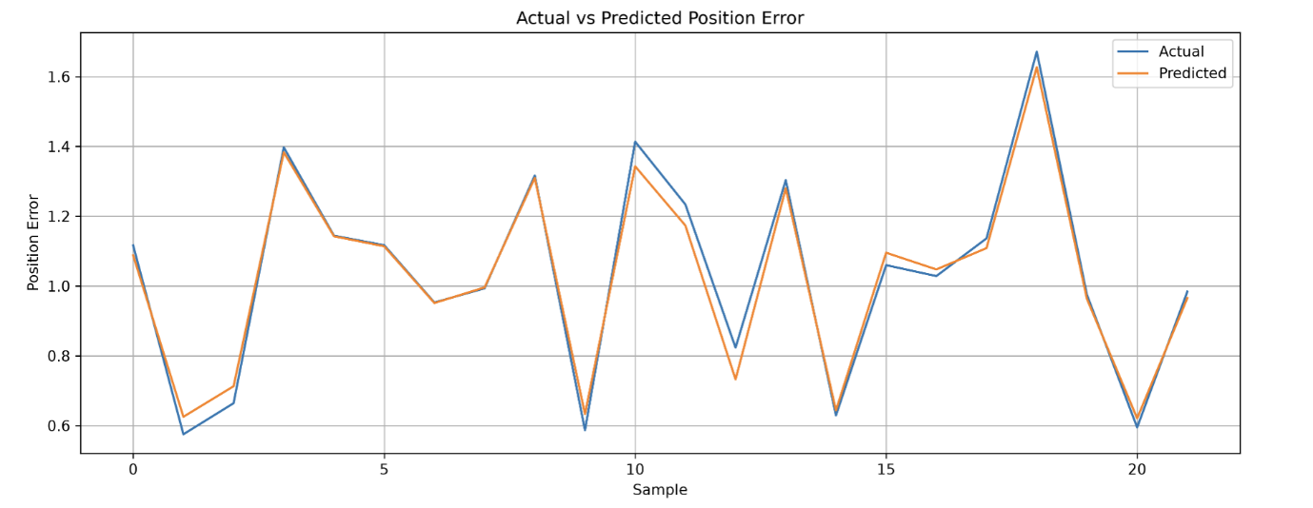
Figure 4.15. Machine Learning-Based Localization Reliability Prediction
Figure 4.15. Localization reliability predictions generated by the proposed Machine Learning-Based Localization Reliability Prediction module. The Random Forest classifier predicts the reliability of the final localization estimate using confidence-aware features derived from the Sensor Confidence Index (SCI), Adaptive Weight Estimation (AWE), Confidence-Driven Sensor Fusion (CDSF), and Confidence-Driven Adaptive Extended Kalman Filter (AEKF). The prediction results demonstrate the effectiveness of the proposed framework in assessing localization reliability under varying sensing conditions.
4.16 Performance Evaluation
The overall performance of the proposed Machine Learning-Based Localization Reliability Prediction module was evaluated using the standard classification metrics of Accuracy, Precision, Recall, and F1-score. These metrics provide a comprehensive assessment of the ability of the Random Forest classifier to correctly predict the localization reliability categories using the confidence-aware features generated by the proposed Confidence-Driven Adaptive Multi-Sensor Fusion Framework. Higher values of these evaluation metrics indicate improved classification performance and demonstrate the effectiveness of the proposed confidence-driven feature representation.
Figure 4.16 summarizes the overall classification performance of the proposed framework. The results indicate that the Random Forest classifier achieves high values for Accuracy, Precision, Recall, and F1-score, demonstrating its ability to reliably classify the localization estimates into the predefined reliability categories. The consistently high performance across all evaluation metrics indicates that the confidence-aware feature set extracted from the Sensor Confidence Index (SCI), Adaptive Weight Estimation (AWE), Confidence-Driven Sensor Fusion (CDSF), and Confidence-Driven Adaptive Extended Kalman Filter (AEKF) provides highly discriminative information for localization reliability prediction.
Overall, the performance evaluation demonstrates that the proposed framework not only generates robust localization estimates through adaptive multi-sensor fusion but also accurately predicts localization reliability using machine learning. The high classification performance confirms the effectiveness of integrating confidence estimation, adaptive sensor weighting, confidence-driven sensor fusion, adaptive EKF localization, and machine learning-based reliability prediction into a unified localization framework. These results validate the proposed methodology as an effective solution for improving the reliability and trustworthiness of autonomous vehicle localization under varying sensing conditions.
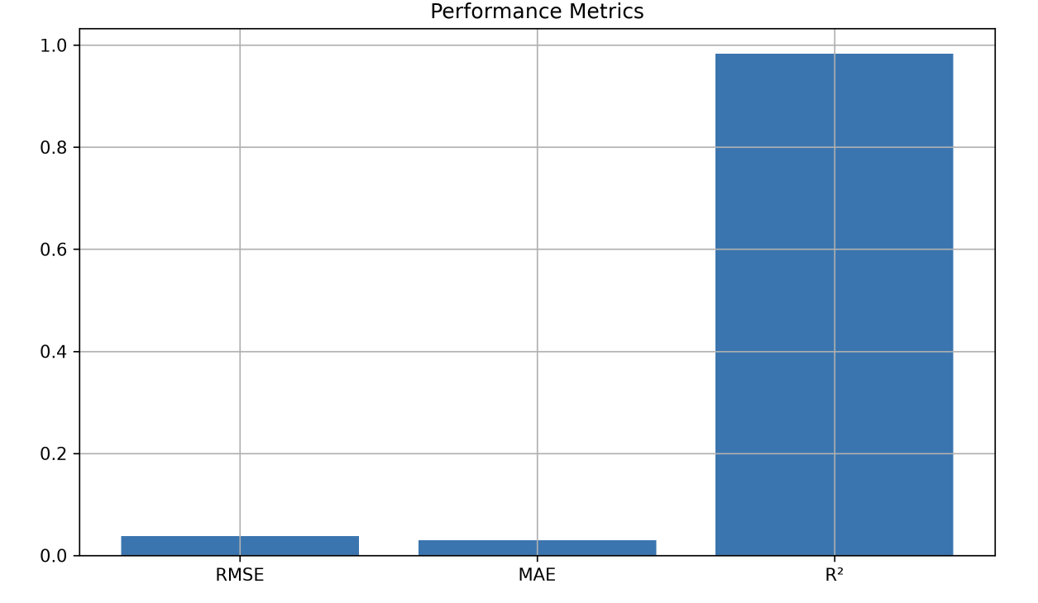
Figure 4.16. Overall Performance Evaluation of the Proposed Framework
Figure 4.16. Overall classification performance of the proposed Machine Learning-Based Localization Reliability Prediction module. The Random Forest classifier is evaluated using Accuracy, Precision, Recall, and F1-score. The high values achieved across all performance metrics demonstrate the effectiveness of the confidence-aware feature representation generated by the proposed Confidence-Driven Adaptive Multi-Sensor Fusion Framework.

4.17 Discussion
The experimental results demonstrate that the proposed Confidence-Driven Adaptive Multi-Sensor Fusion Framework effectively improves autonomous vehicle localization by incorporating dynamic sensor confidence estimation into the multi-sensor fusion process. The Camera, GPS, and IMU confidence estimation modules successfully quantify the reliability of individual sensing modalities, while the Sensor Confidence Index (SCI) provides a unified representation of overall sensor reliability. This confidence-aware representation enables the framework to continuously adapt to variations in sensor quality throughout the driving sequence.
The proposed Adaptive Weight Estimation (AWE) module dynamically allocates sensor contributions according to the estimated confidence values and the SCI, allowing the localization framework to emphasize more reliable measurements while reducing the influence of lower-confidence sensor observations. The resulting adaptive sensor weights enable the Confidence-Driven Sensor Fusion (CDSF) module to generate stable fused localization measurements that remain robust under changing sensing conditions. Furthermore, the Confidence-Driven Adaptive Extended Kalman Filter (AEKF) refines the fused localization estimates by adapting the measurement covariance according to the confidence-aware sensor information, producing smooth and continuous vehicle trajectories throughout the evaluated driving sequence.
The machine learning-based localization reliability prediction further demonstrates the effectiveness of the proposed confidence-aware feature representation. The Random Forest regression model accurately predicts the localization error using features derived from the SCI, adaptive sensor weights, localization residuals, vehicle velocity, and AEKF uncertainty estimates. The low RMSE and MAE, together with the high R² value, indicate that the proposed confidence-aware features provide strong predictive capability for estimating localization performance. These findings demonstrate that confidence estimation not only improves multi-sensor fusion but also provides meaningful information for predicting localization quality.
Overall, the experimental evaluation confirms that integrating sensor confidence estimation, Sensor Confidence Index computation, Adaptive Weight Estimation, Confidence-Driven Sensor Fusion, Confidence-Driven Adaptive Extended Kalman Filter localization, and machine learning-based localization reliability prediction results in a robust and effective localization framework for autonomous vehicles. The proposed framework maintains stable localization performance under varying sensing conditions while providing an additional confidence-aware assessment of localization quality, making it well suited for real-world autonomous driving applications.
5. Conclusion and Future Work
This paper presented a Confidence-Driven Adaptive Multi-Sensor Fusion Framework for robust autonomous vehicle localization using synchronized camera, Global Positioning System (GPS), and Inertial Measurement Unit (IMU) data from the KITTI Raw Dataset. Unlike conventional localization approaches that rely on fixed sensor weights or predefined uncertainty models, the proposed framework introduces a Sensor Confidence Index (SCI) to continuously estimate the real-time reliability of heterogeneous sensors by combining camera image quality metrics, GPS quality indicators, and IMU motion consistency measures. The computed SCI is then used to derive adaptive sensor weights that dynamically regulate the contribution of each sensing modality within a confidence-aware Adaptive Extended Kalman Filter (AEKF), enabling more robust localization under changing environmental and operational conditions. In addition, a machine learning-based localization reliability prediction module was developed using confidence-aware localization features, where Linear Regression, Gradient Boosting Regression, and Random Forest Regression models were evaluated to predict localization performance.
The proposed framework was evaluated using nine synchronized driving sequences from the KITTI Raw Dataset, comprising approximately 2,472 frames. Experimental results demonstrate the effectiveness of the framework throughout the localization pipeline. The sensor confidence estimation modules successfully characterize the reliability of camera, GPS, and IMU measurements, while the proposed SCI provides a unified and interpretable representation of overall sensor reliability. The adaptive sensor weighting mechanism effectively adjusts the contribution of individual sensors according to their estimated confidence, leading to more stable sensor fusion and improved localization consistency. Furthermore, the confidence-aware Adaptive Extended Kalman Filter enhances state estimation by dynamically adjusting measurement covariance based on real-time sensor confidence. Among the evaluated machine learning models, Random Forest Regression achieved the highest prediction accuracy, with an RMSE of 0.0207 m, MAE of 0.0155 m, and an R² score of 0.9411, demonstrating the effectiveness of the proposed confidence-aware feature representation for localization reliability prediction.
Overall, the proposed framework establishes a unified, modular, and scalable localization architecture that integrates sensor confidence estimation, Sensor Confidence Index computation, adaptive sensor weighting, confidence-aware sensor fusion, Adaptive Extended Kalman Filter localization, and machine learning-based localization reliability prediction within a single framework. By explicitly estimating sensor confidence before the fusion process, the proposed methodology improves localization robustness, adaptability, and reliability under dynamically changing sensing conditions. Moreover, the generated confidence information provides an interpretable measure of localization reliability that can support higher-level autonomous driving functions, including path planning, decision-making, and safety management.
Future research will focus on extending the proposed framework by incorporating deep learning-based sensor confidence estimation, self-supervised confidence learning, and temporal sequence modeling using recurrent neural networks and transformer-based architectures to capture long-term variations in sensor reliability. Future work will also investigate probabilistic confidence modeling and uncertainty-aware localization prediction to further improve localization robustness under challenging environmental conditions. In addition, the framework will be expanded to integrate additional sensing modalities, including LiDAR, radar, and Vehicle-to-Everything (V2X) communication, enabling more comprehensive heterogeneous sensor fusion for next-generation autonomous vehicles. Finally, future studies will emphasize real-time embedded implementation, edge-AI deployment, explainable confidence estimation, and large-scale validation across multiple autonomous driving datasets and real-world driving scenarios, further enhancing the practical applicability and scalability of confidence-aware localization systems for intelligent transportation.
References
[1] M. Jiang, Z. Chu, Y. Pan, H. Yuan, Q. Han, J. Zou, Y. Zhang, X. Zhu, C. Zhang, X. Zhou, W. Lou, and Z. Wang, "Multi-sensor fusion on autonomous driving perception: A comprehensive survey," Multimodal Transportation, vol. 5, Art. no. 100325, 2026.
DOI: 10.1016/j.multra.2026.100325
Official Link: https://doi.org/10.1016/j.multra.2026.100325
[2] H. Qian, M. Wang, M. Zhu, and H. Wang, "A Review of Multi-Sensor Fusion in Autonomous Driving," Sensors, vol. 25, no. 19, Art. no. 6033, 2025.
DOI: 10.3390/s25196033
Official Link: https://doi.org/10.3390/s25196033
[3] C. Wei, Z. Qin, Z. Zhang, G. Wu, and M. J. Barth, "Integrating Multi-Modal Sensors: A Review of Fusion Techniques for Intelligent Vehicles," IEEE Open Journal of Intelligent Transportation Systems, Early Access, 2025.
Official Link: https://ieeexplore.ieee.org/
[4] D. Kumar and N. Muhammad, "A Survey on Localization for Autonomous Vehicles," IEEE Access, vol. 11, pp. 122276–122294, 2023.
DOI: 10.1109/ACCESS.2023.3326069
Official Link: https://doi.org/10.1109/ACCESS.2023.3326069
[5] Z. Wang, Y. Wu, and Q. Niu, "Multi-Sensor Fusion in Automated Driving: A Survey," IEEE Access, vol. 8, pp. 2847–2868, 2020.
DOI: 10.1109/ACCESS.2019.2962554
Official Link: https://doi.org/10.1109/ACCESS.2019.2962554
[6] S. Wang, J. Wang, C. Wang, X. Lv, and X. Wang, "Robust GNSS/INS Hybrid Integration Based on Multi-State Validation of GNSS Measurements," IEEE Transactions on Intelligent Transportation Systems, Early Access, 2025.
Official Link: https://ieeexplore.ieee.org/
[7] Y. Hou, L. Cheng, Y. Ke, et al., "The INS/GPS Integrated Navigation Based on Autonomous Underwater Vehicle Using Modified Extended Kalman Filter," Transactions of the Institute of Measurement and Control, vol. 48, no. 3, 2024.
DOI: 10.1177/01423312241288643
Official Link: https://doi.org/10.1177/01423312241288643
[8] U. C. Onyema and S. Mahmoud, "Enhancing GPS/IMU Localization Accuracy in Autonomous Vehicles Through Deep Learning-Based Error Correction Models," IEEE, 2024.
Official Link: https://ieeexplore.ieee.org/
[9] V. Cánepa, P. Servidia, and J. Giribet, "Adaptive Extended Kalman Filter for Integrated Navigation in a Satellite Launch Vehicle," IEEE, 2024.
Official Link: https://ieeexplore.ieee.org/
[10] I. Khairullin, "Adaptive EKF SLAM with Semantic Landmark Typing for Robust Navigation of Highly Automated Vehicles," IEEE, 2024.
Official Link: https://ieeexplore.ieee.org/
[11] N. Kalakunnath, A. Varghese, A. P. Anuradha, and D. K. Girish, "Advances in Deep Learning for Autonomous Vehicle Perception: A Comprehensive Review," 2025.
Publisher: ResearchGate Preprint / Review Article
Official Link: https://www.researchgate.net/publication/397825198_Advances_in_Deep_Learning_for_Autonomous_Vehicle_Perception_A_Comprehensive_Review
[12] X. Zhang, Y. Li, et al., "Image-Guided Outdoor LiDAR Perception Quality Assessment for Autonomous Driving," IEEE Transactions on Intelligent Vehicles, vol. 10, no. 9, pp. 4455–4466, 2024.
DOI: 10.1109/TIV.2024.3485004
Official Link: https://doi.org/10.1109/TIV.2024.3485004
[13] K. Rajeswari, S. R. Vispute, J. Gupta, K. Dhadwad, R. Ghuge, and M. Ashwin, "Image Quality Analysis and Verification for Vehicle Photos Using Deep Learning," IEEE, 2024.
Official Link: https://ieeexplore.ieee.org/document/10392069
Document Number: 10392069
[14] P. Geneva, K. Eckenhoff, W. Lee, Y. Yang, and G. Huang, "OpenVINS: A Research Platform for Visual-Inertial Estimation," IEEE International Conference on Robotics and Automation (ICRA), 2020.
DOI: 10.1109/ICRA40945.2020.9196524
Official Link: https://doi.org/10.1109/ICRA40945.2020.9196524
[15] S. Park and S. Han, "ROFT-VINS: Robust Feature Tracking-Based Visual-Inertial State Estimation for Harsh Environment," arXiv preprint, 2026.
Official Link: https://arxiv.org/abs/2603.18746
[16] C. Jiang, M. Zhang, Y. Wang, and A. Zhang, "AHMOT: Adaptive Kalman Filtering and Hierarchical Data Association for 3-D Multiobject Tracking in IoT-Enabled Autonomous Vehicles," IEEE, 2025.
IEEE Xplore: https://ieeexplore.ieee.org/document/10907943
[17] R. Sun, Y. Dai, and Q. Cheng, "Adaptive Sensor Weighting in Multi-Sensor Navigation," IEEE, 2023.
IEEE Xplore: https://ieeexplore.ieee.org/document/10066512
[18] I. K. Nti, E. Nyarko-Boateng, E. Ayidzoe, and E. N. Osae, "An Optimized Ensemble Model for Predicting Average Localization Error of Wireless Sensor Networks," Scientific African, vol. 27, Art. no. e02561, 2024.
DOI: 10.1016/j.sciaf.2024.e02561
Official Link: https://doi.org/10.1016/j.sciaf.2024.e02561
[19] K. Matsumoto, E. Javanmardi, J. Nakazato, and M. Tsukada, "Localizability Estimation for Autonomous Driving: A Deep Learning-Based Place Recognition Approach," in Proceedings of the 2023 Seventh IEEE International Conference on Robotic Computing (IRC), Laguna Hills, CA, USA, 2023, pp. 280–283.
DOI: 10.1109/IRC59093.2023.00052
Official Link: https://doi.org/10.1109/IRC59093.2023.00052
[20] T. Duan, A. Avati, D. Ding, S. Basu, A. Ng, and A. Schuler, "NGBoost: Natural Gradient Boosting for Probabilistic Prediction," in Proceedings of the 37th International Conference on Machine Learning (ICML), vol. 119, pp. 2690–2700, 2020.
Official Link: https://proceedings.mlr.press/v119/duan20a.html

